Geometric Figures

Definition
# Source: AI Source: Provided by: [Data Path: Persons Table -> ID Column: 1, Name_En Column: Motasem Essam] -> From: [ChatGPT] on [7/25/2026]
Geometric Figures are mathematical objects defined by points, lines, curves, angles, surfaces, or combinations of these elements. They are used to represent and study shape, size, position, distance, and spatial relationships in geometry.
Geometric figures may exist in two dimensions (2D), such as triangles and circles, or three dimensions (3D), such as cubes and spheres.
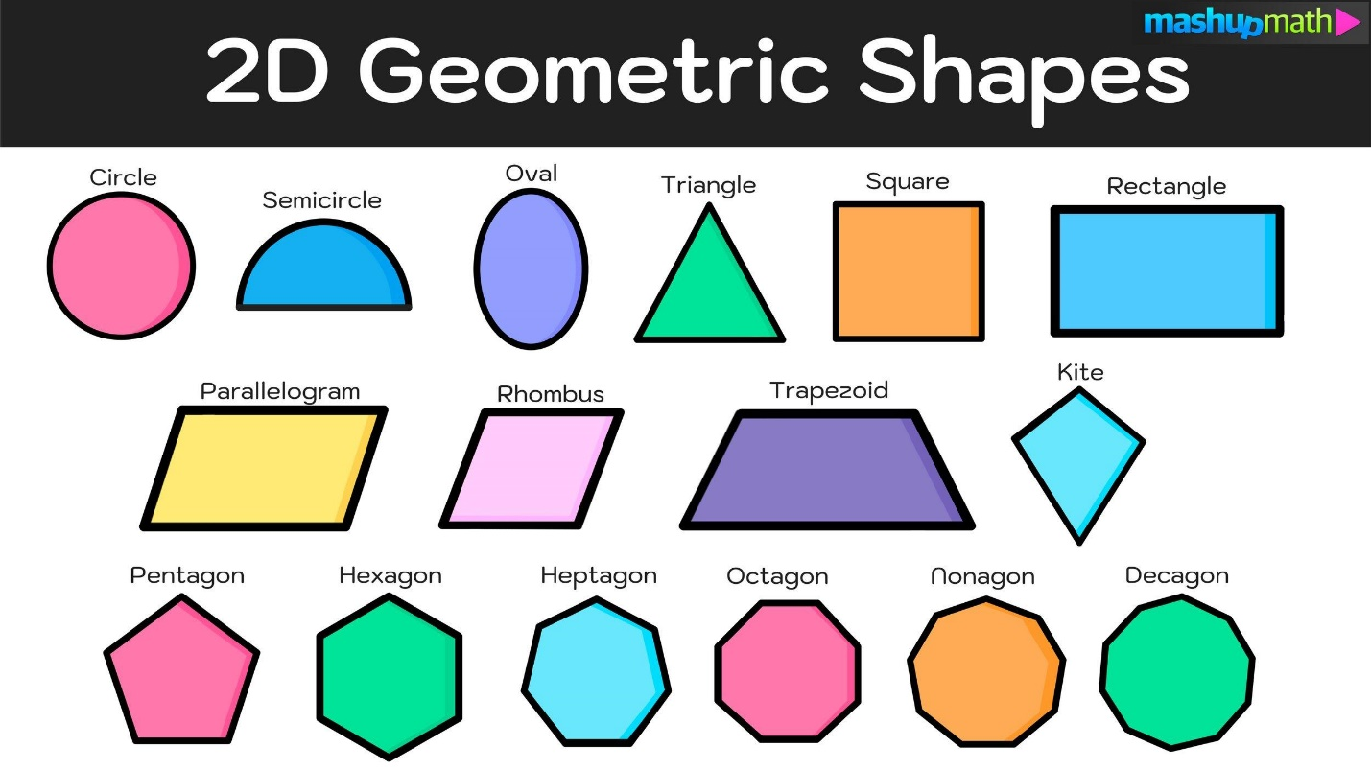
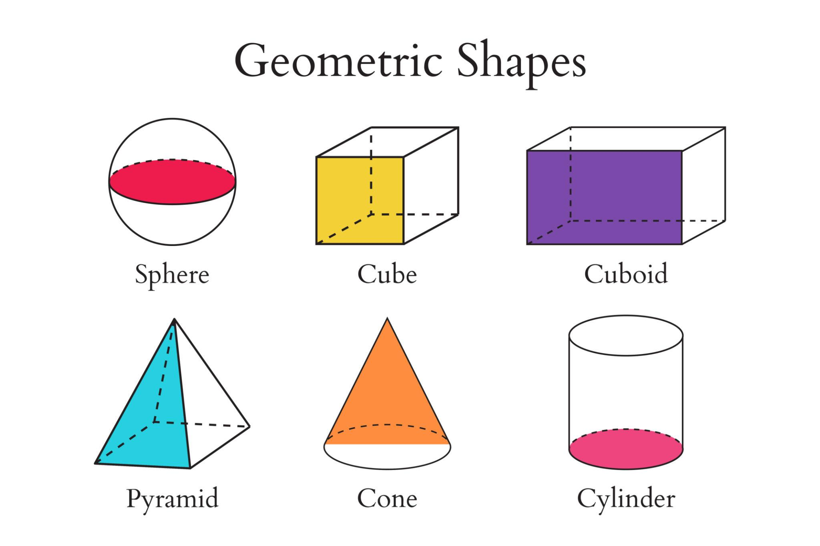
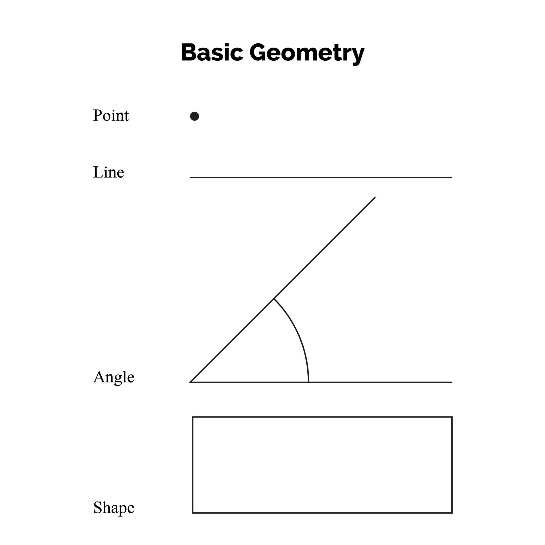
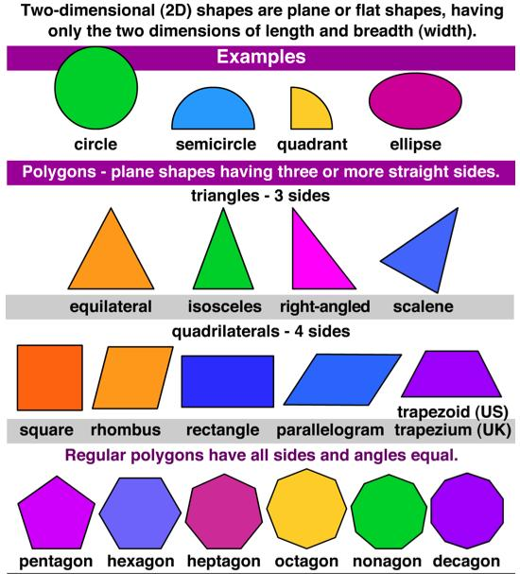
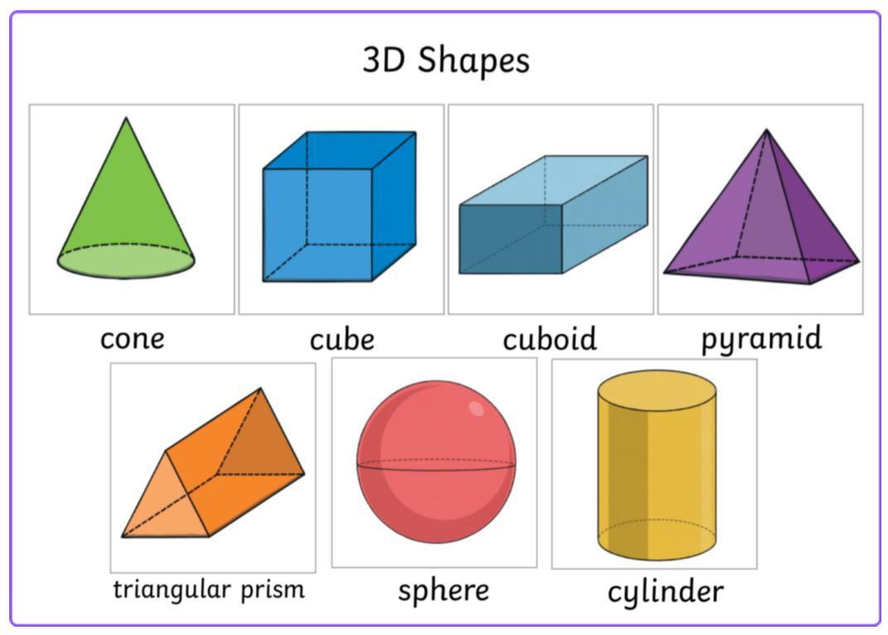
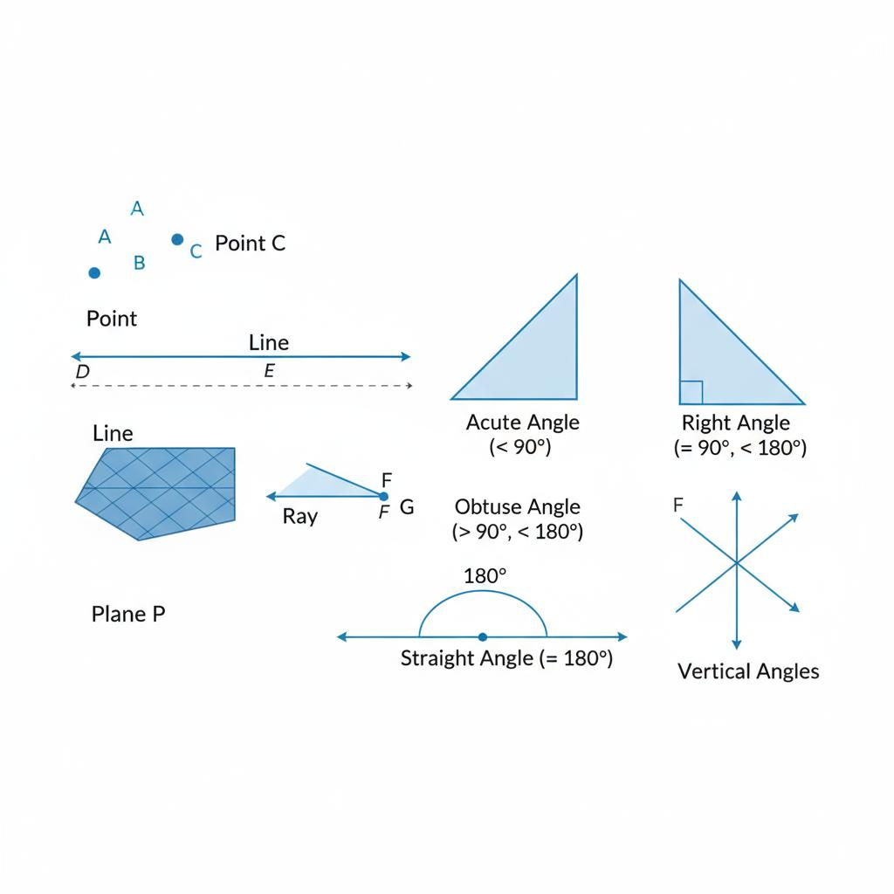
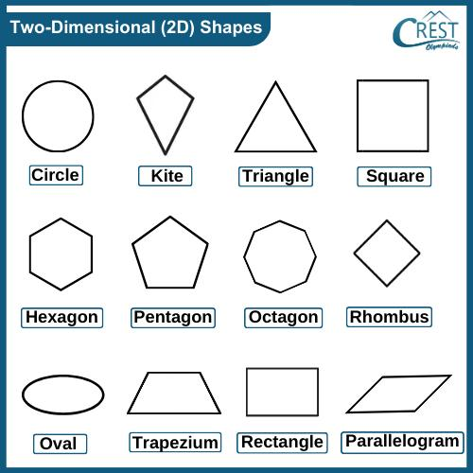

Purpose
# Source: AI Source: Provided by: [Data Path: Persons Table -> ID Column: 1, Name_En Column: Motasem Essam] -> From: [ChatGPT] on [7/25/2026]
Geometric figures are used to:
- Represent mathematical shapes and objects.
- Study geometric properties.
- Measure lengths, distances, angles, perimeters, areas, surface areas, and volumes.
- Compare different shapes.
- Identify geometric relationships.
- Solve geometric problems.
- Model real-world objects and structures.
- Support engineering, architecture, design, and computer graphics.

Fundamental Elements
# Source: AI Source: Provided by: [Data Path: Persons Table -> ID Column: 1, Name_En Column: Motasem Essam] -> From: [ChatGPT] on [7/25/2026]
Many geometric figures are constructed from basic geometric elements.

Point
# Source: AI Source: Provided by: [Data Path: Persons Table -> ID Column: 1, Name_En Column: Motasem Essam] -> From: [ChatGPT] on [7/25/2026]
A point represents an exact location.
Properties:
- No length.
- No width.
- No thickness.
Notation:
$$A, B, P$$
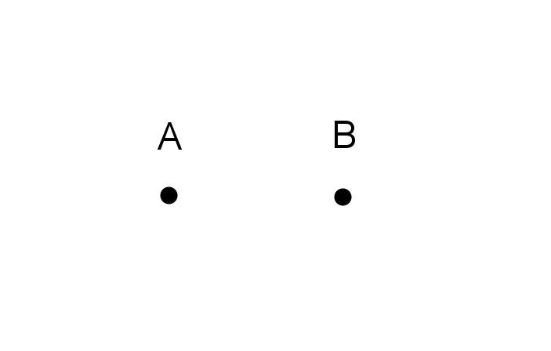
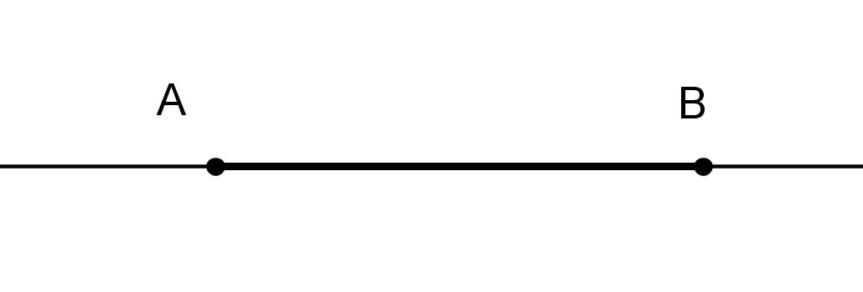
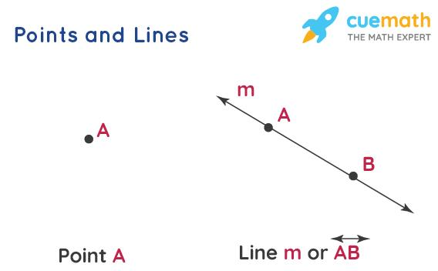
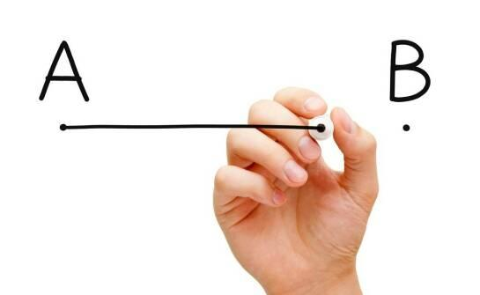
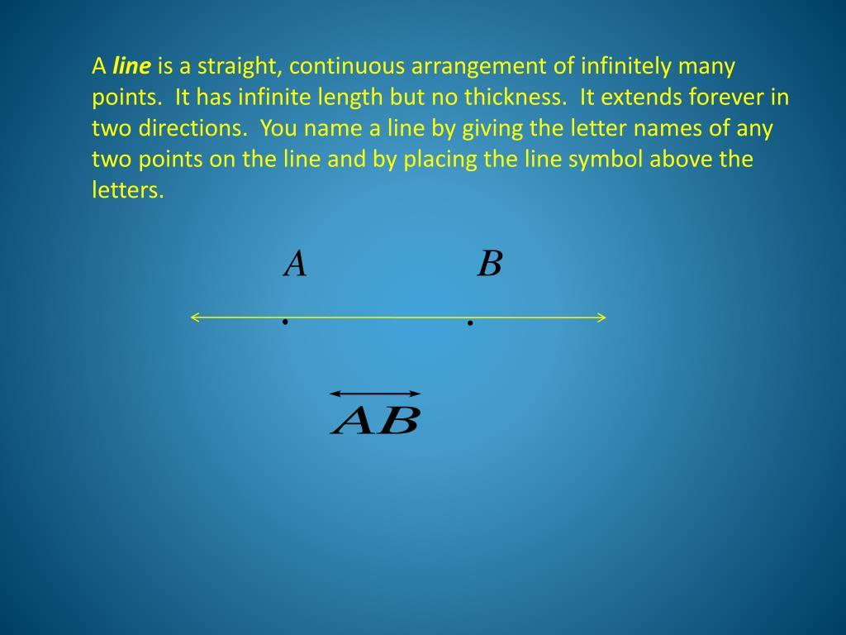

Line
# Source: AI Source: Provided by: [Data Path: Persons Table -> ID Column: 1, Name_En Column: Motasem Essam] -> From: [ChatGPT] on [7/25/2026]
A line is a straight path extending infinitely in both directions.
Notation:
$$\overset{↔}{AB}$$
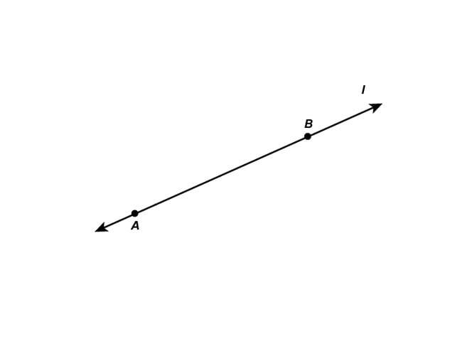
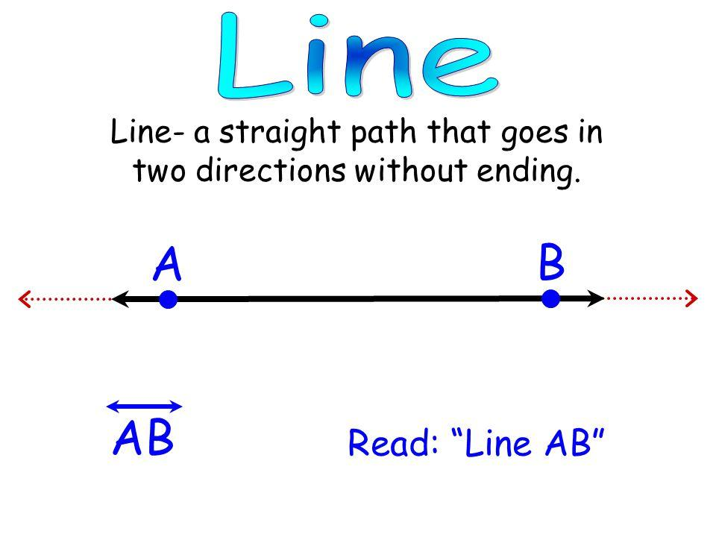
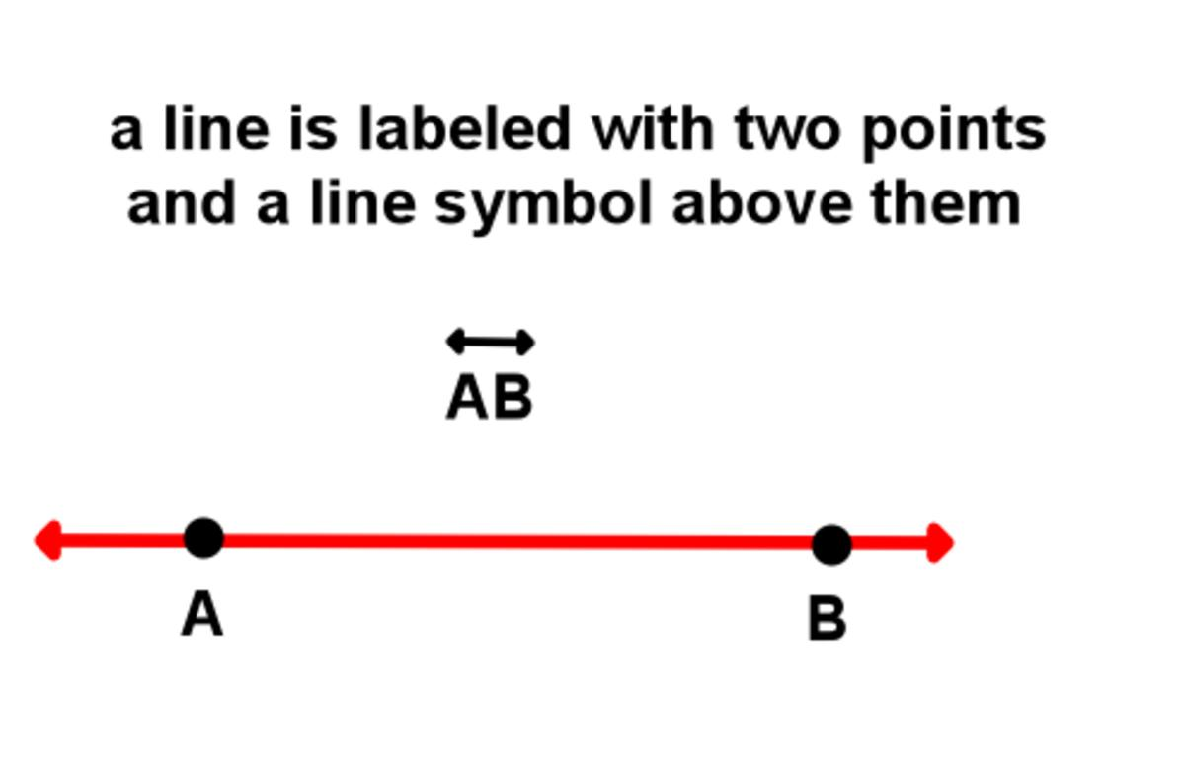
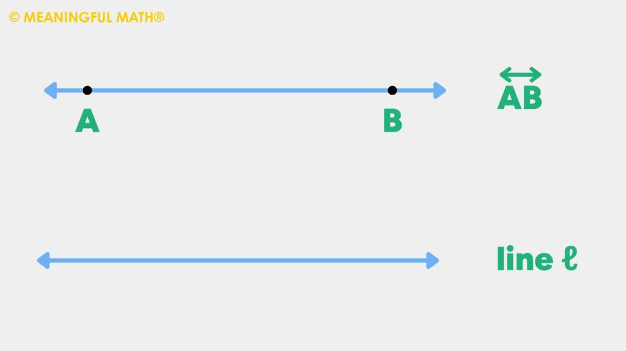

Line Segment
# Source: AI Source: Provided by: [Data Path: Persons Table -> ID Column: 1, Name_En Column: Motasem Essam] -> From: [ChatGPT] on [7/25/2026]
A line segment is a part of a line with two endpoints.
Notation:
$$\overline{AB}$$
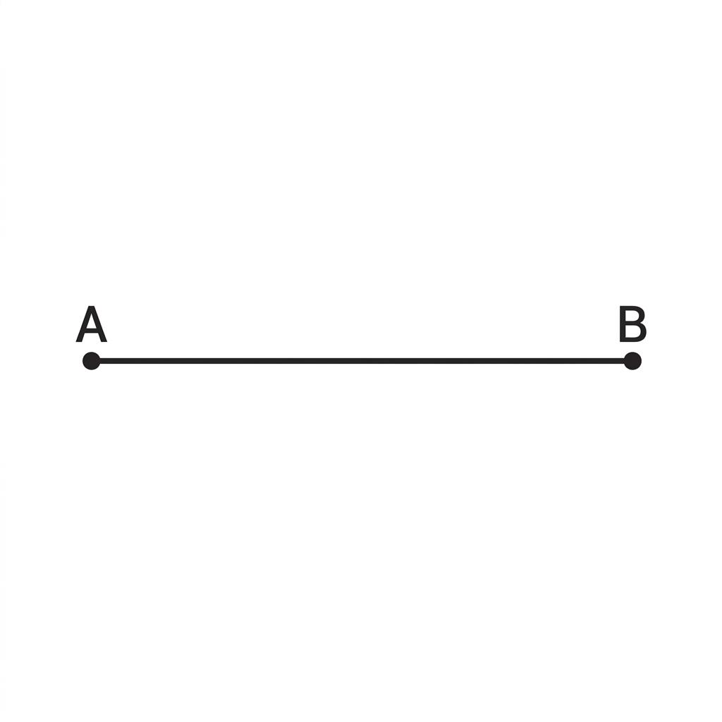
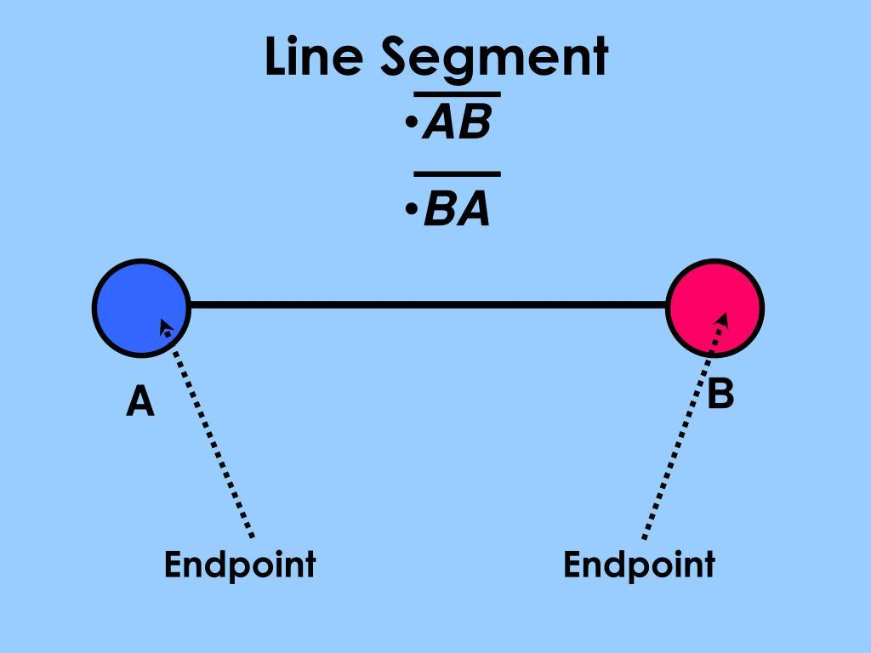
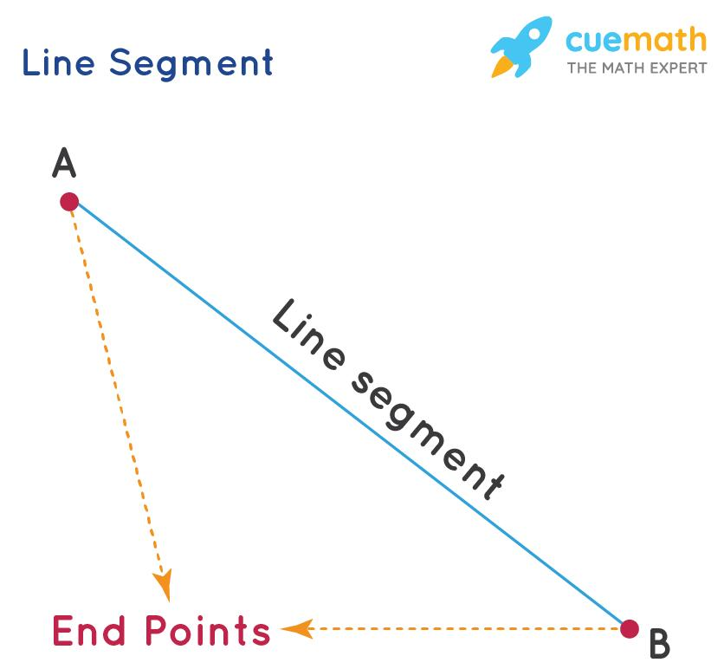
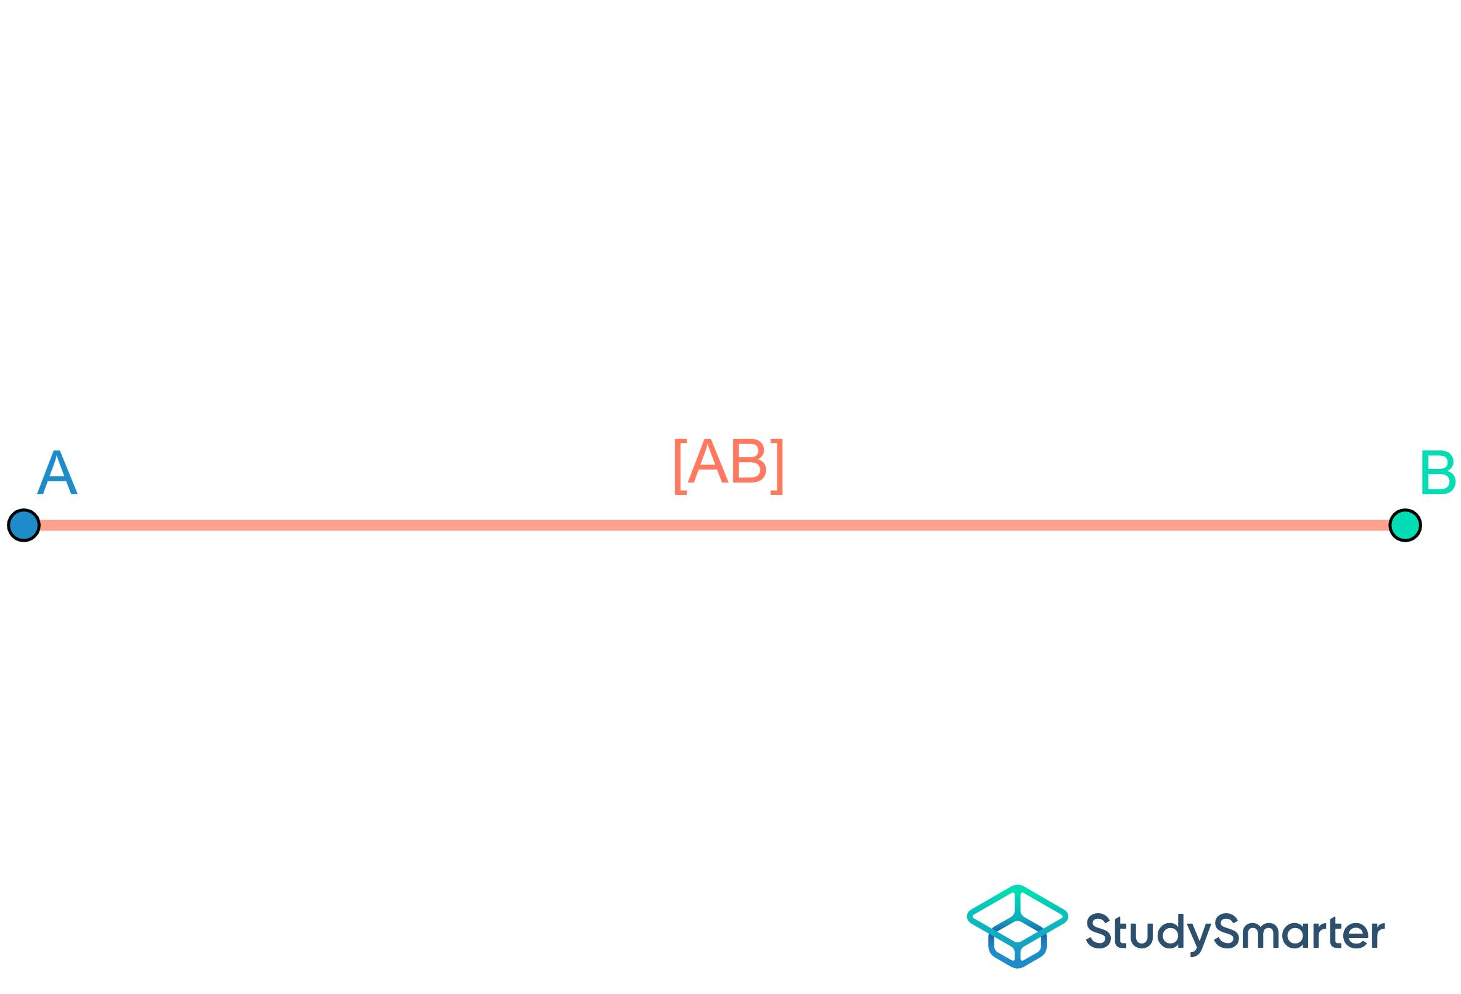
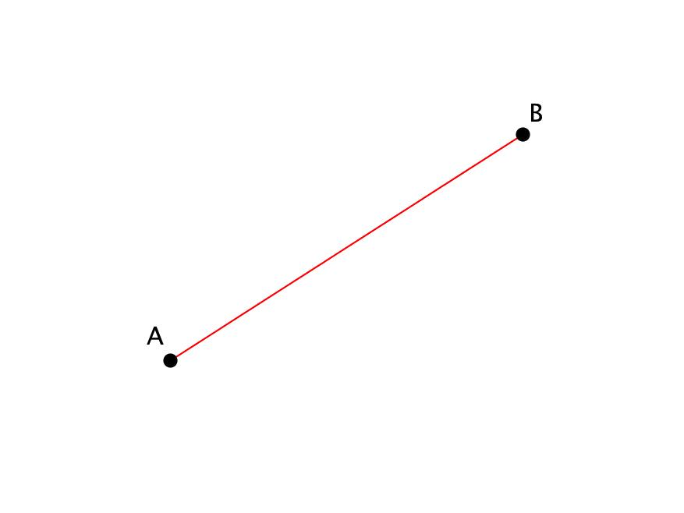

Ray
# Source: AI Source: Provided by: [Data Path: Persons Table -> ID Column: 1, Name_En Column: Motasem Essam] -> From: [ChatGPT] on [7/25/2026]
A ray begins at one endpoint and extends infinitely in one direction.
Notation:
$$\overset{→}{AB}$$
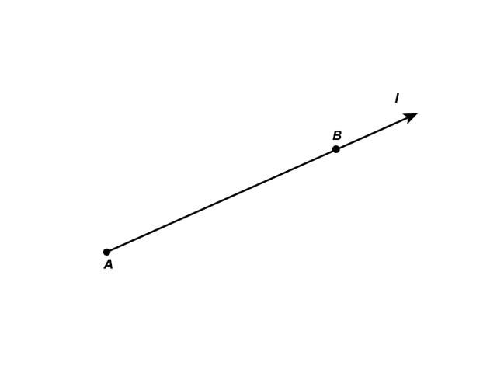
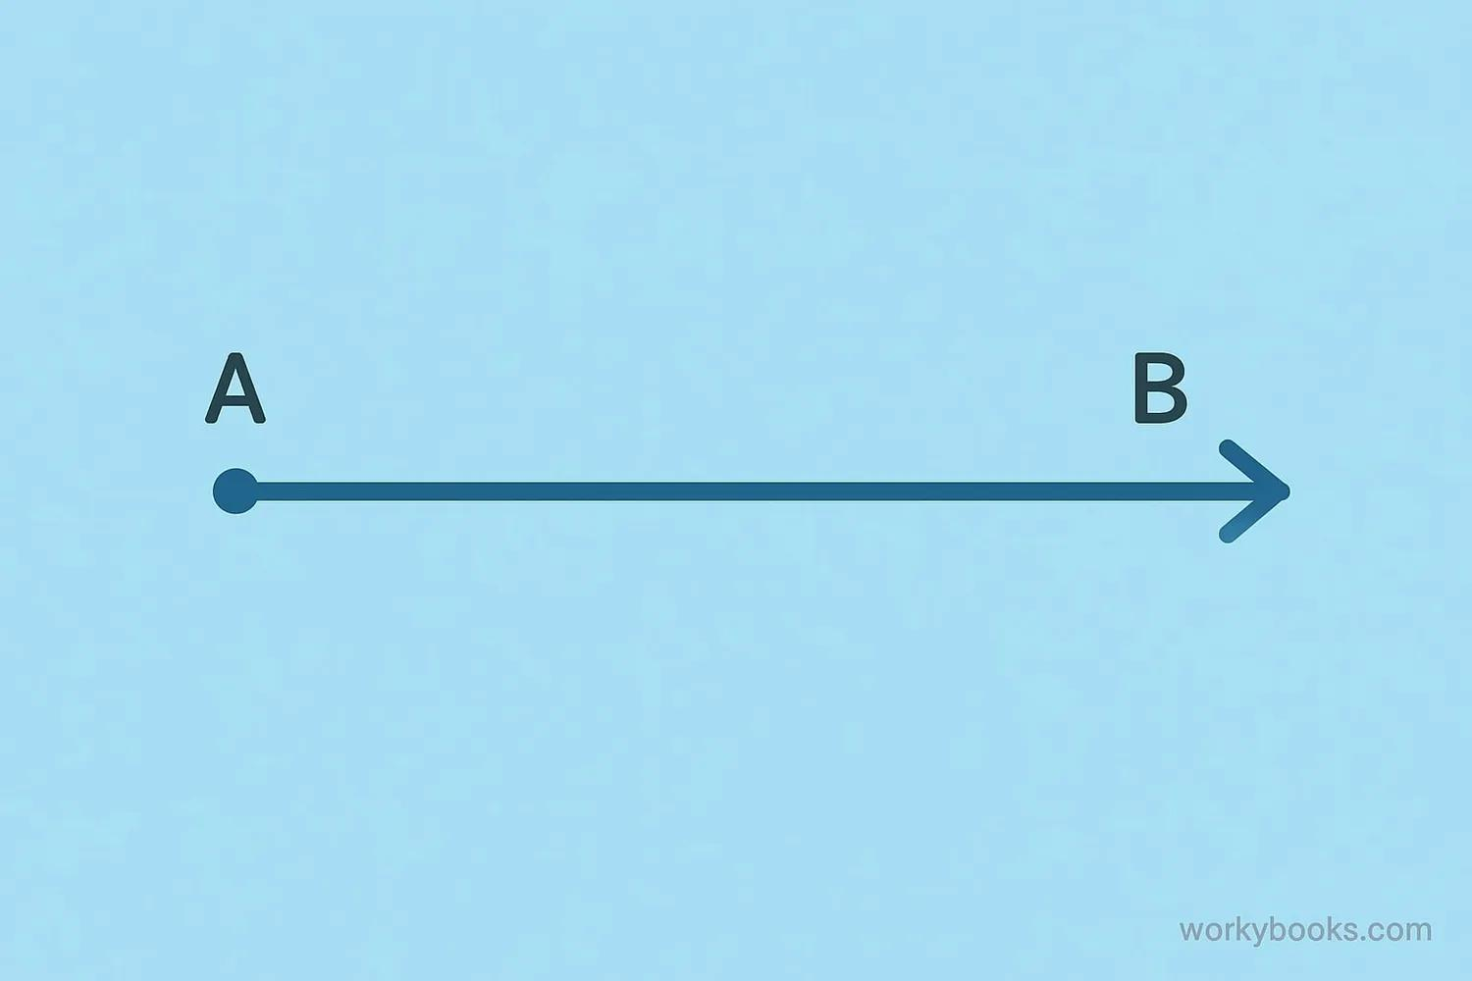
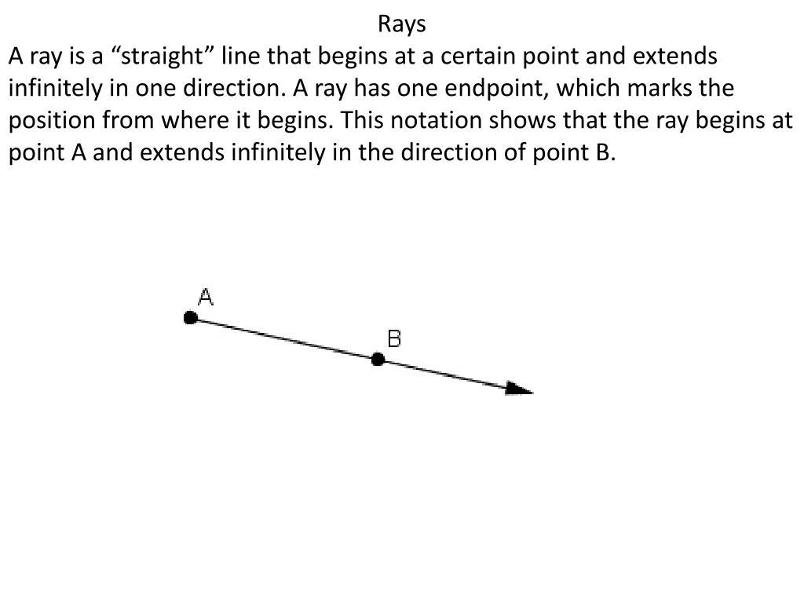
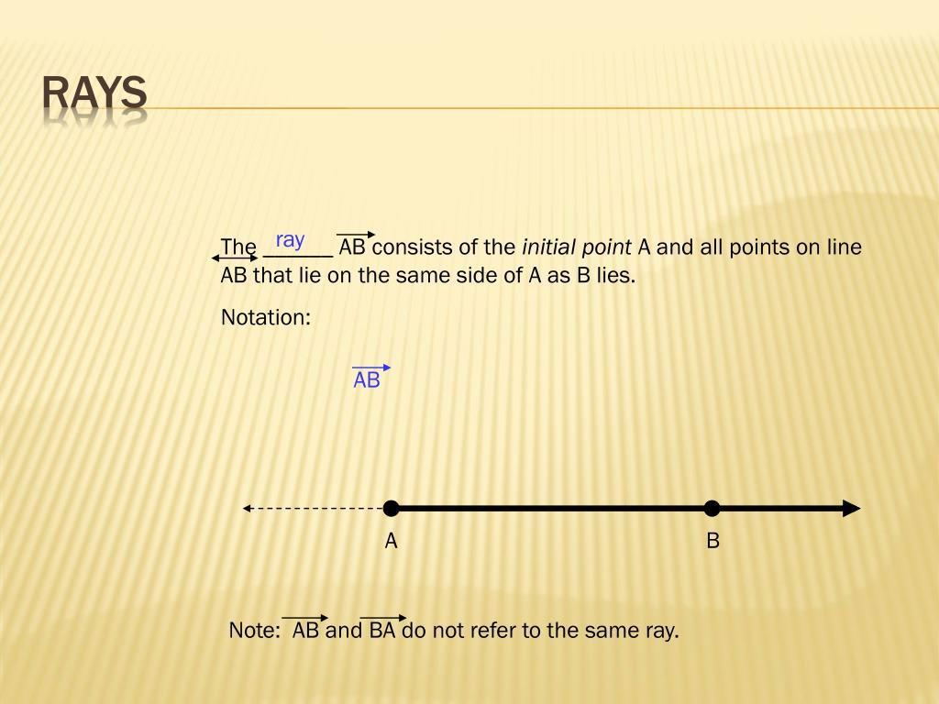
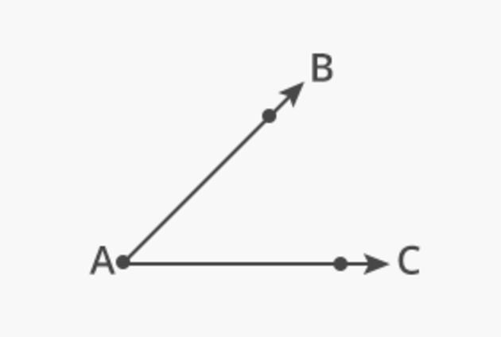

Angle
# Source: AI Source: Provided by: [Data Path: Persons Table -> ID Column: 1, Name_En Column: Motasem Essam] -> From: [ChatGPT] on [7/25/2026]
An angle is formed by two rays that share a common endpoint called the vertex.
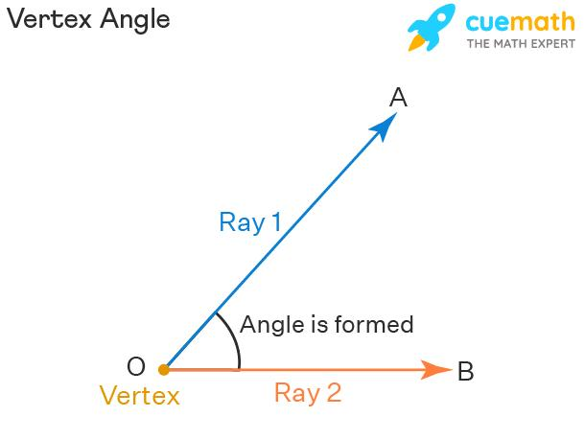
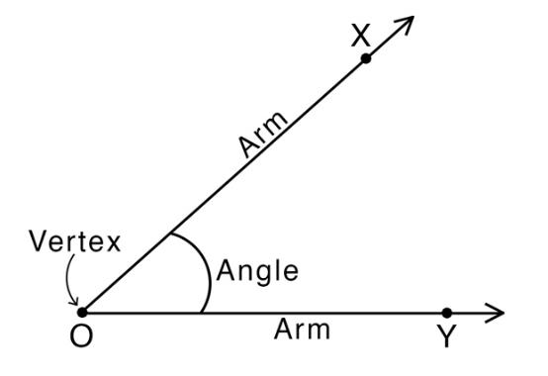
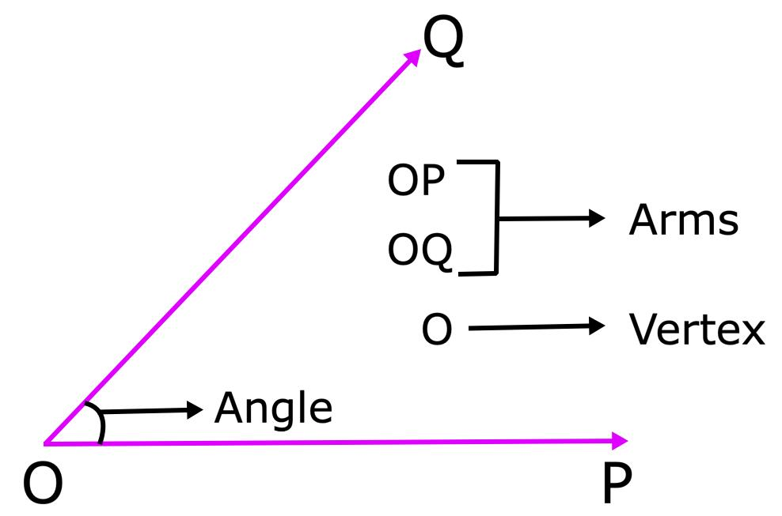
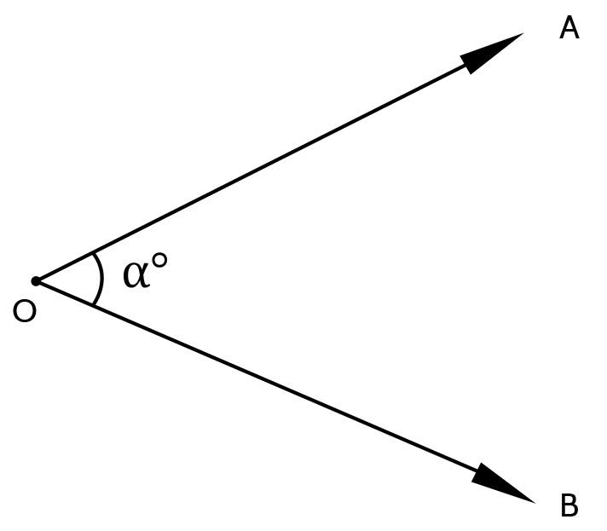

Classification of Geometric Figures
# Source: AI Source: Provided by: [Data Path: Persons Table -> ID Column: 1, Name_En Column: Motasem Essam] -> From: [ChatGPT] on [7/25/2026]
Geometric figures can be broadly classified according to their dimensions.

1. Zero-Dimensional Figures
# Source: AI Source: Provided by: [Data Path: Persons Table -> ID Column: 1, Name_En Column: Motasem Essam] -> From: [ChatGPT] on [7/25/2026]
These have no measurable length, width, or area.
Example:
- Point

2. One-Dimensional Figures
# Source: AI Source: Provided by: [Data Path: Persons Table -> ID Column: 1, Name_En Column: Motasem Essam] -> From: [ChatGPT] on [7/25/2026]
These primarily have length.
Examples:
- Line
- Ray
- Line segment
- Curve
- Polyline

3. Two-Dimensional Figures
# Source: AI Source: Provided by: [Data Path: Persons Table -> ID Column: 1, Name_En Column: Motasem Essam] -> From: [ChatGPT] on [7/25/2026]
These have length and width and lie in a plane.
Examples:
- Triangle
- Quadrilateral
- Circle
- Polygon

4. Three-Dimensional Figures
# Source: AI Source: Provided by: [Data Path: Persons Table -> ID Column: 1, Name_En Column: Motasem Essam] -> From: [ChatGPT] on [7/25/2026]
These have length, width, and height/depth.
Examples:
- Cube
- Cuboid
- Sphere
- Cylinder
- Cone
- Prism
- Pyramid
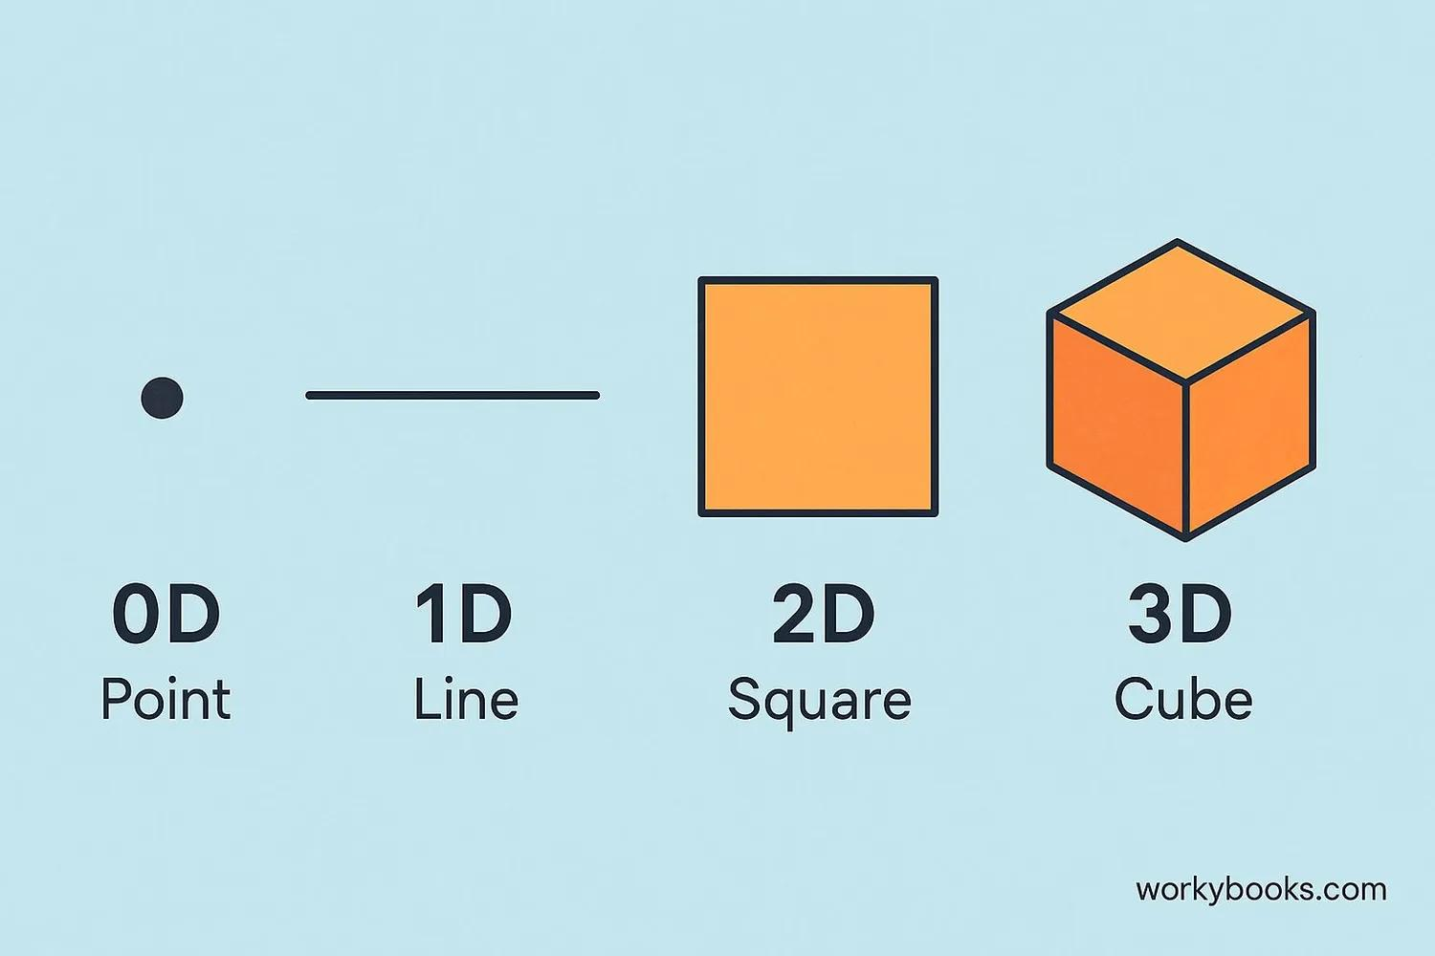
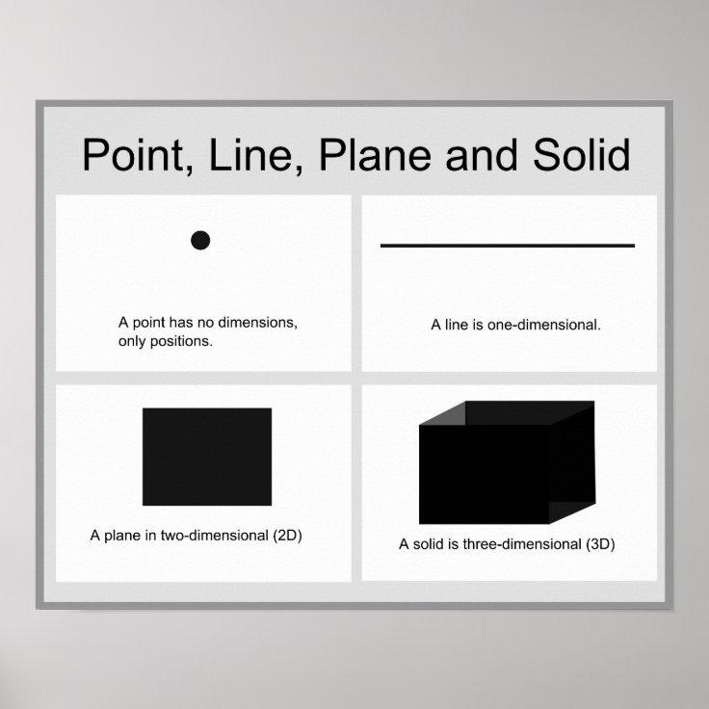
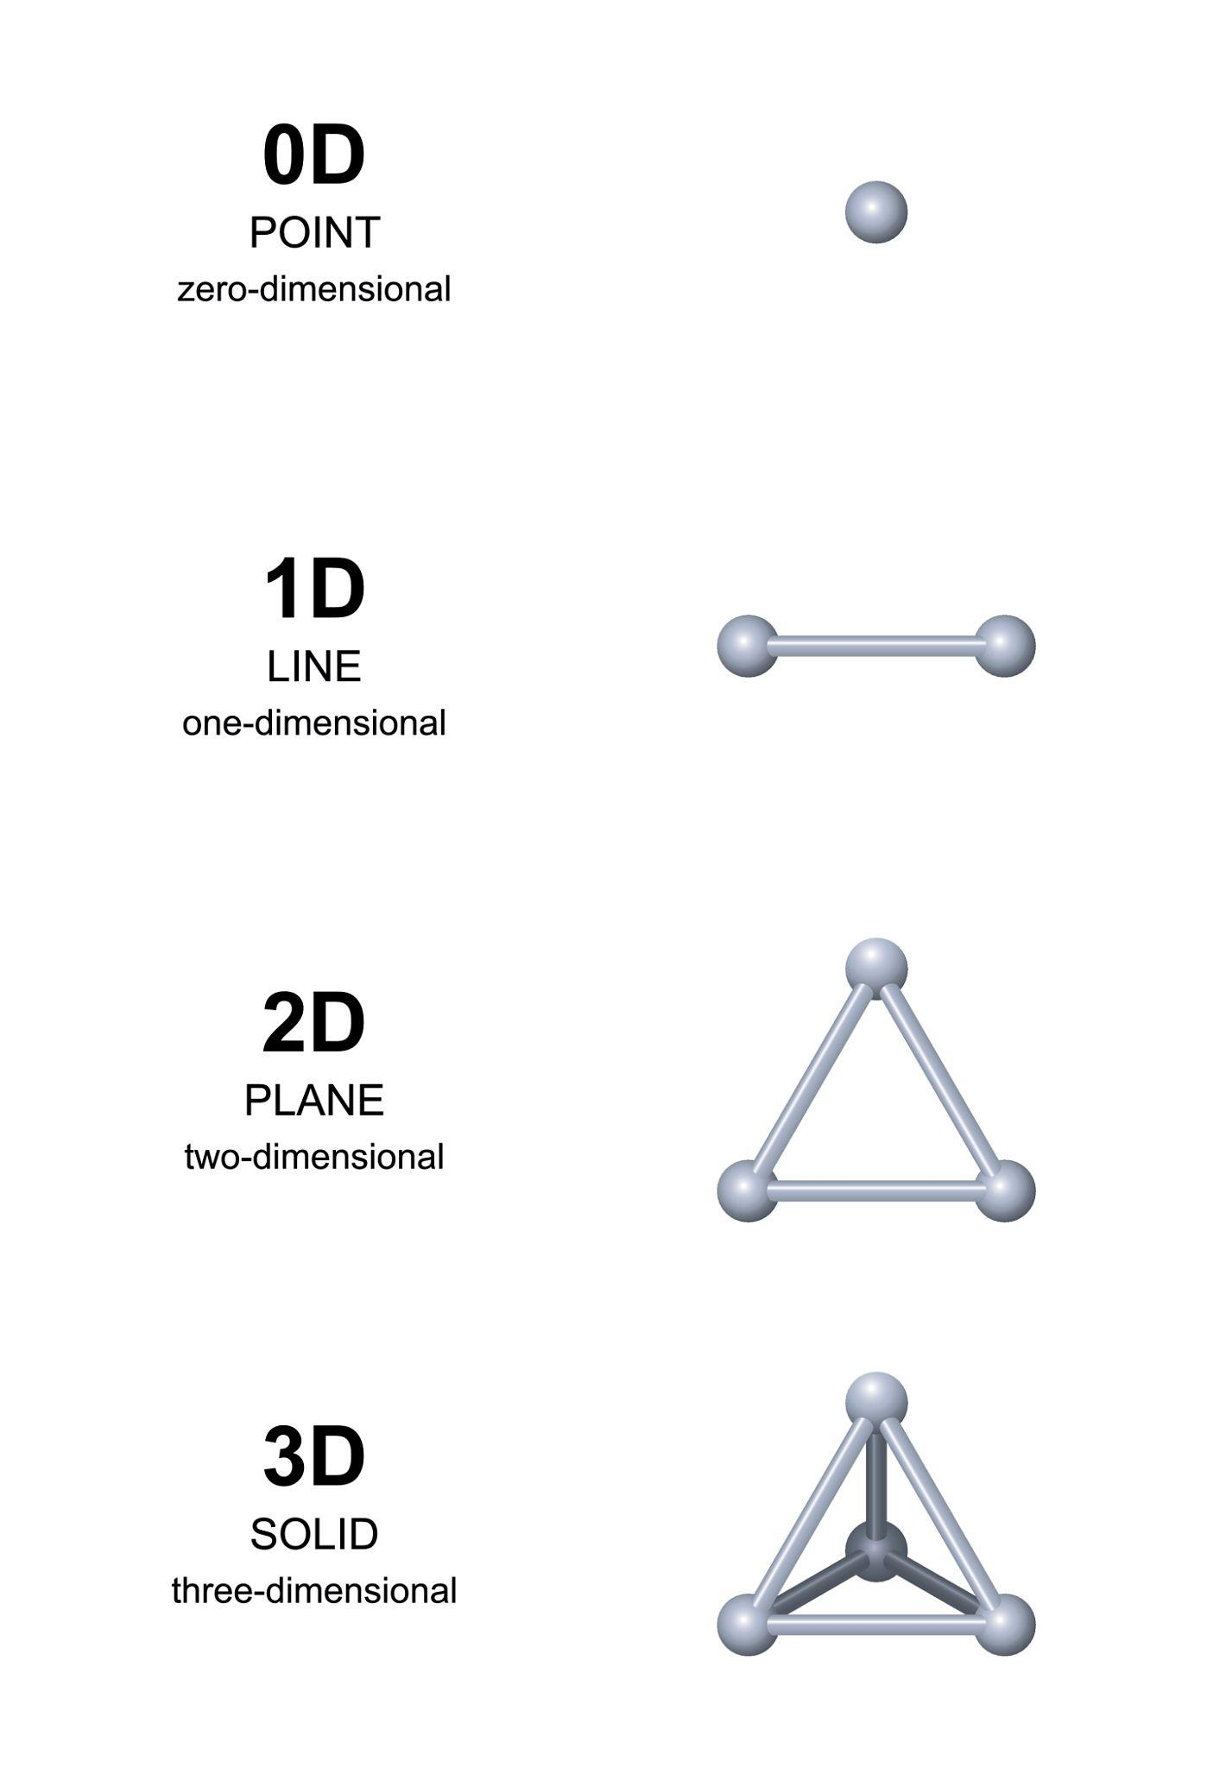
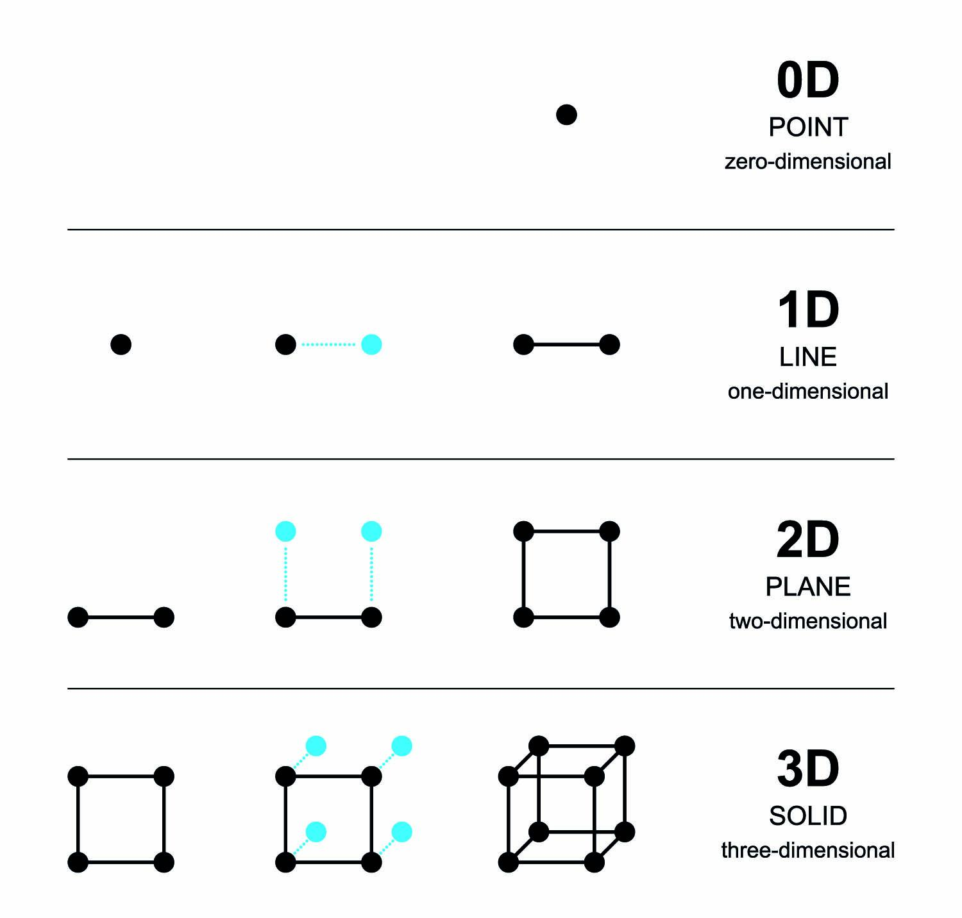
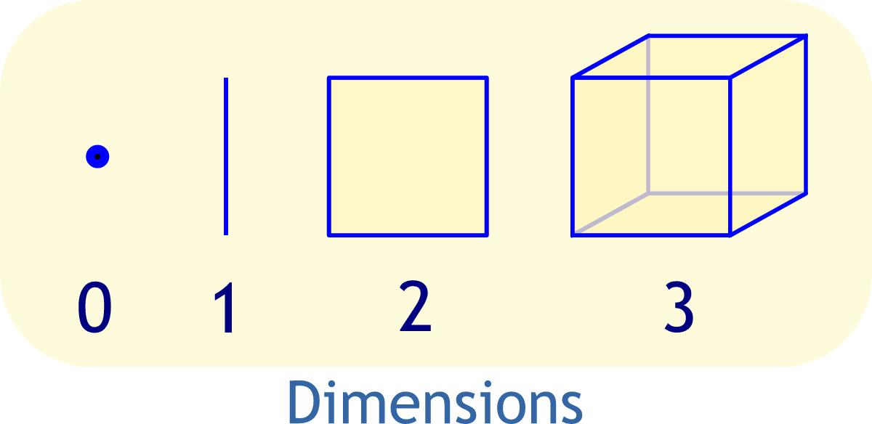

Two-Dimensional Geometric Figures
# Source: AI Source: Provided by: [Data Path: Persons Table -> ID Column: 1, Name_En Column: Motasem Essam] -> From: [ChatGPT] on [7/25/2026]
Two-dimensional (2D) figures are flat figures that can be represented on a plane.
They have:
- Length
- Width
- Perimeter
- Area
Common examples include:
- Triangle
- Square
- Rectangle
  - Parallelogram
- Rhombus
- Trapezoid
- Kite
- Circle
- Polygon
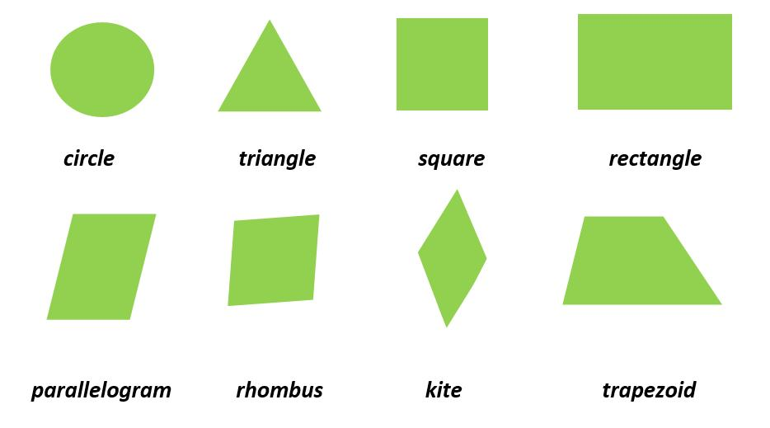
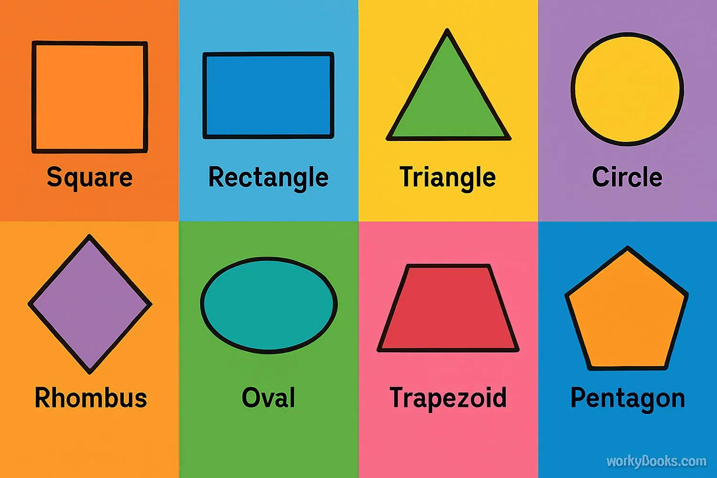
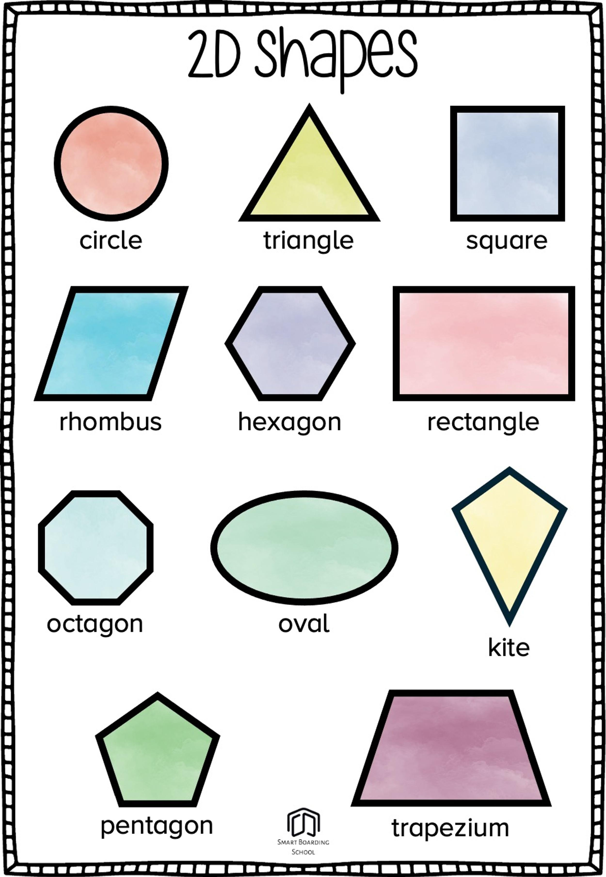
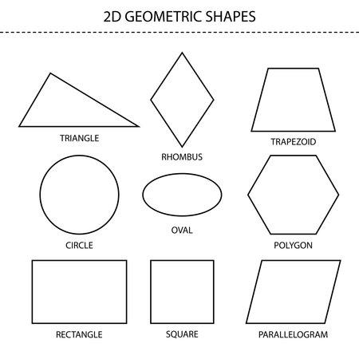

Three-Dimensional Geometric Figures
# Source: AI Source: Provided by: [Data Path: Persons Table -> ID Column: 1, Name_En Column: Motasem Essam] -> From: [ChatGPT] on [7/25/2026]
Three-dimensional (3D) figures occupy space.
They have:
- Length
- Width
- Height or depth
- Surface area
- Volume
Common examples include:
- Cube
- Cuboid
- Sphere
- Cylinder
- Cone
- Prism
- Pyramid
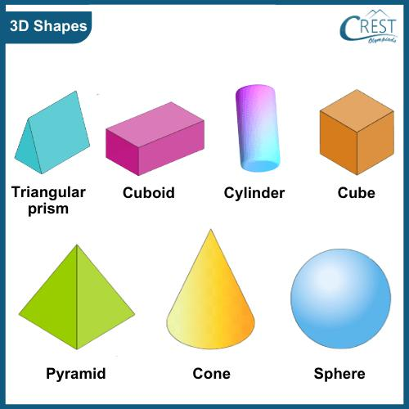
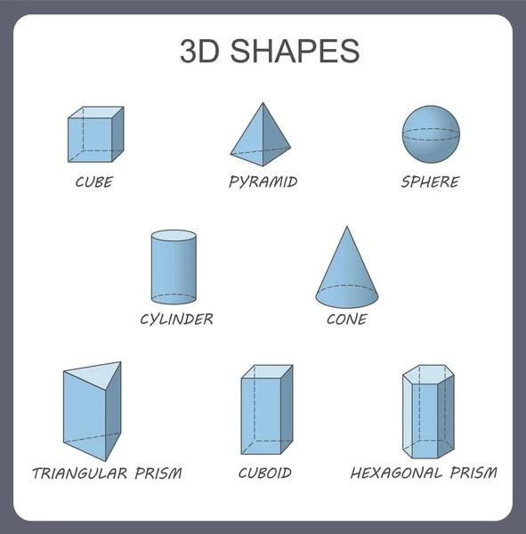
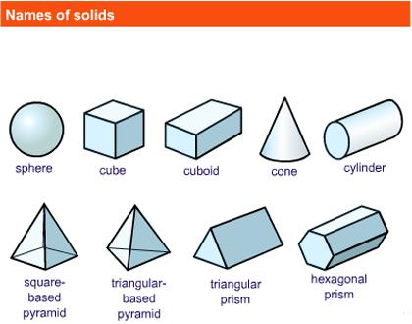
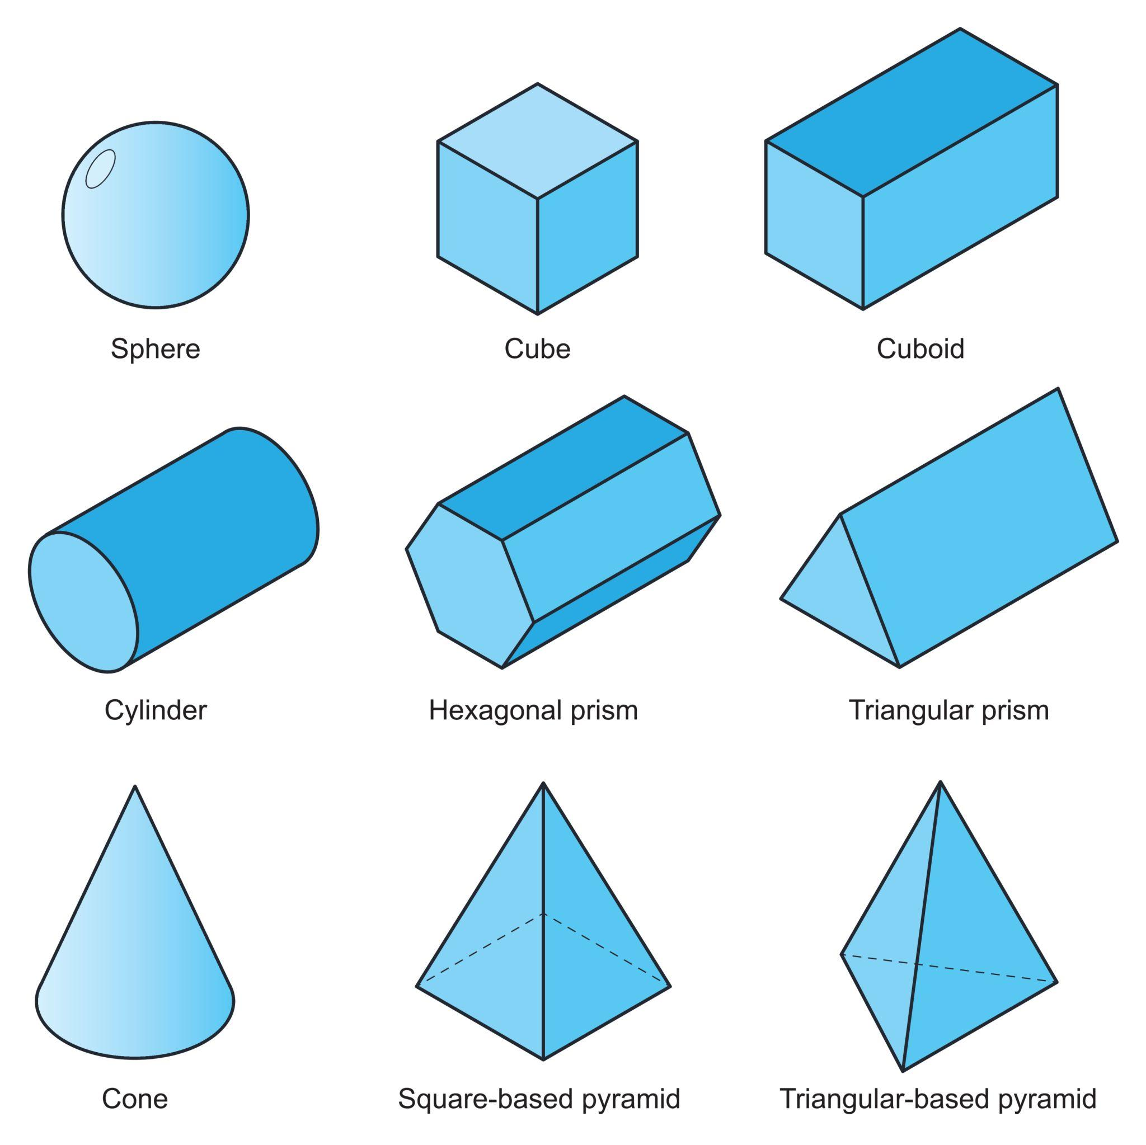

Common Geometric Figures

Triangle
# Source: AI Source: Provided by: [Data Path: Persons Table -> ID Column: 1, Name_En Column: Motasem Essam] -> From: [ChatGPT] on [7/25/2026]
A triangle is a polygon with three sides and three angles.
Types by sides:
- Equilateral
- Isosceles
- Scalene
Types by angles:
- Acute
- Right
- Obtuse
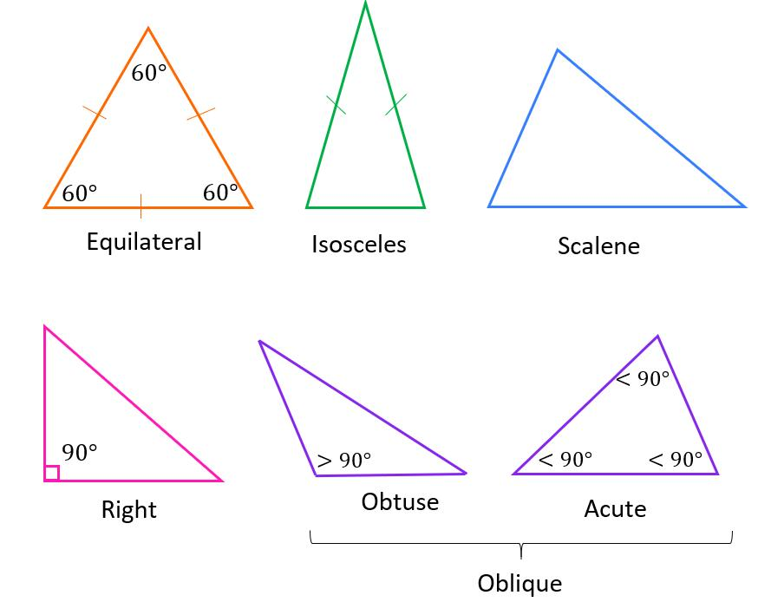
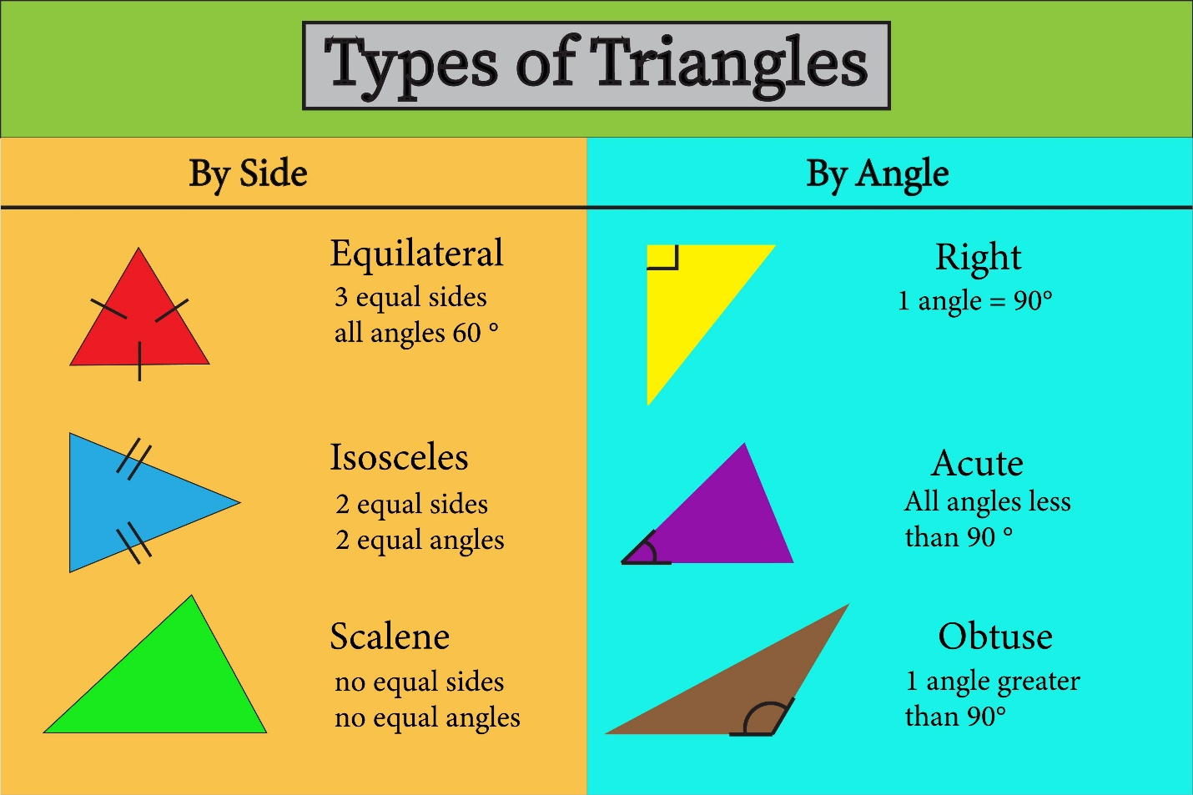
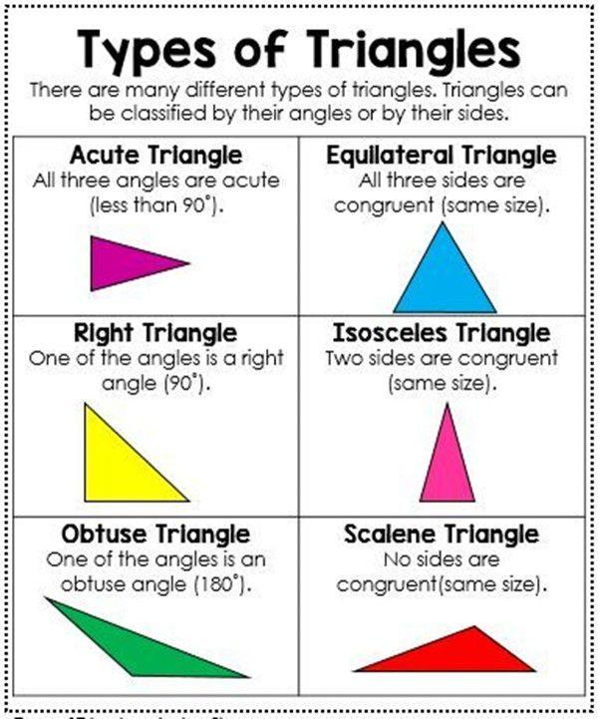
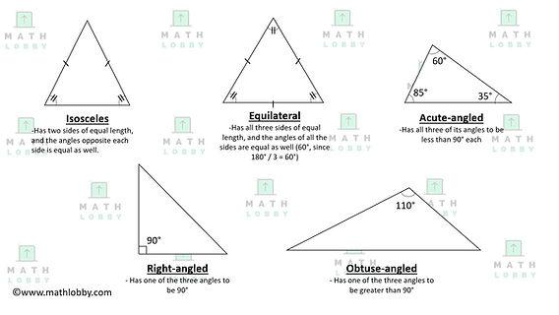
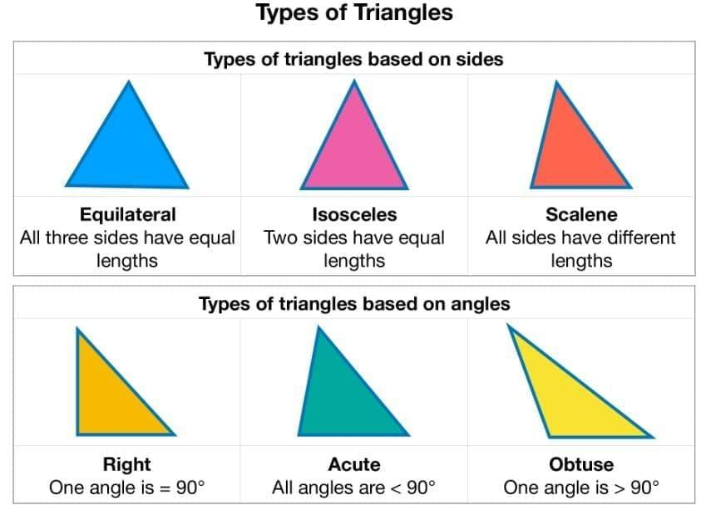

Quadrilateral
# Source: AI Source: Provided by: [Data Path: Persons Table -> ID Column: 1, Name_En Column: Motasem Essam] -> From: [ChatGPT] on [7/25/2026]
A quadrilateral is a polygon with four sides.
Examples:
- Square
- Rectangle
- Parallelogram
- Rhombus
- Trapezoid
- Kite
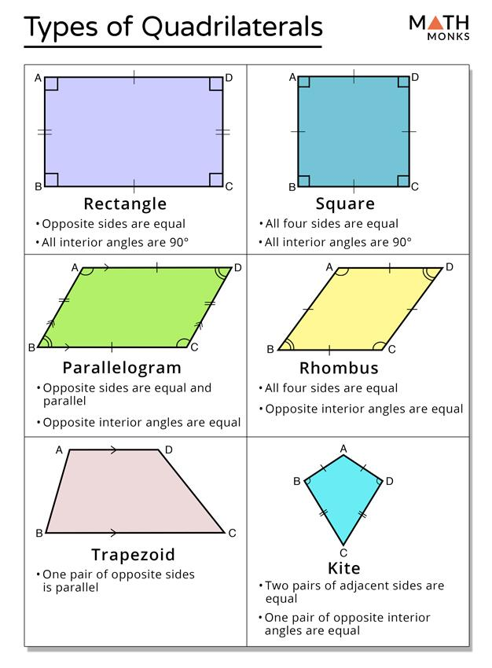
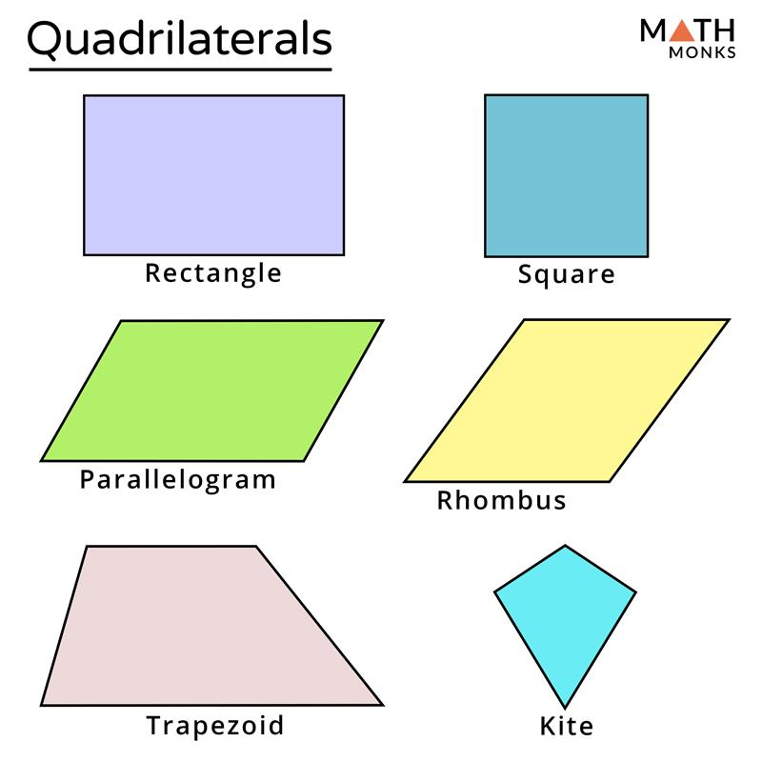
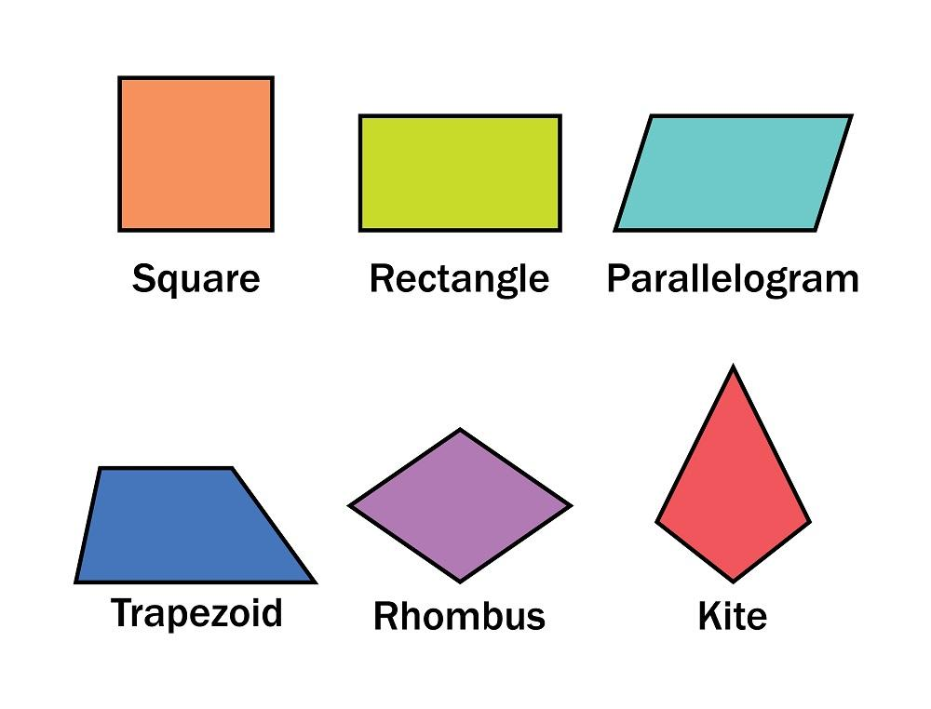
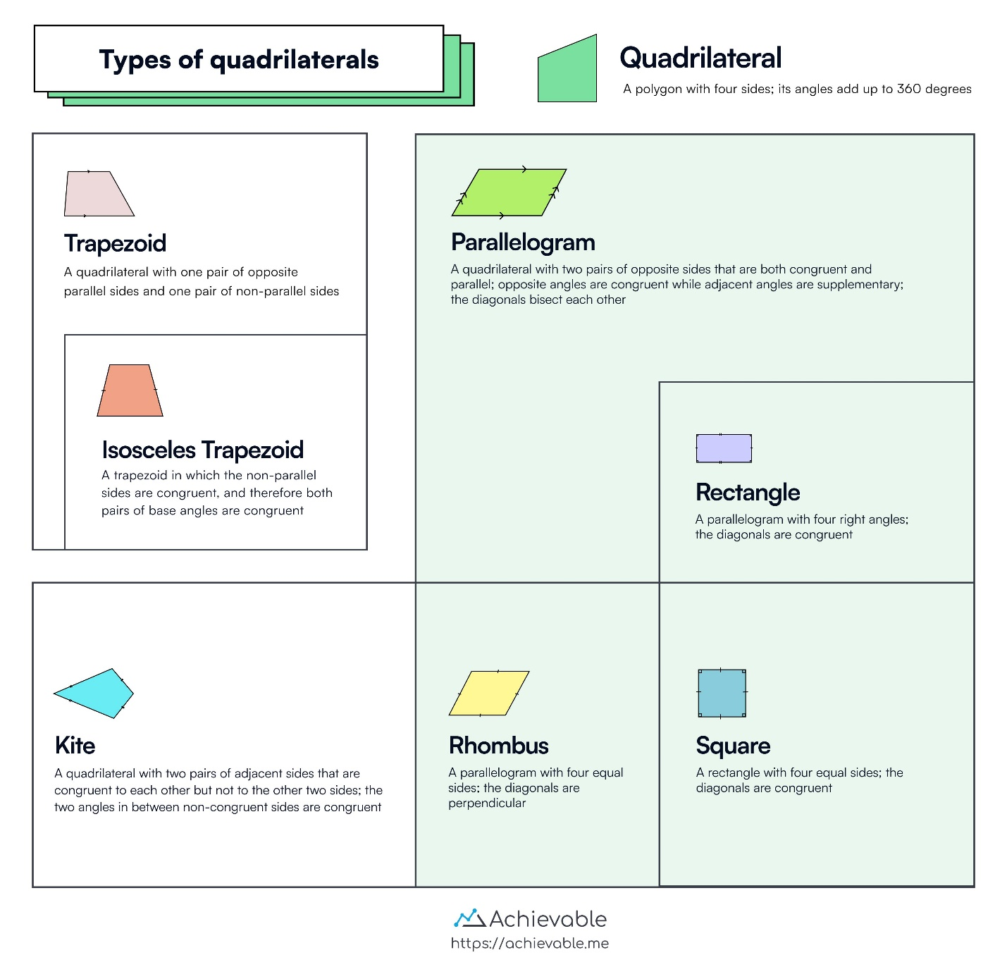
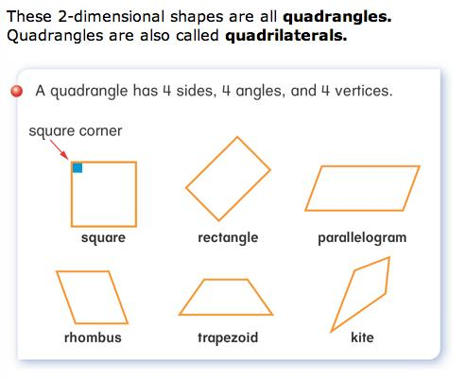

Circle
# Source: AI Source: Provided by: [Data Path: Persons Table -> ID Column: 1, Name_En Column: Motasem Essam] -> From: [ChatGPT] on [7/25/2026]
A circle is the set of all points in a plane that are a fixed distance from a given point called the center.
Important parts include:
- Center
- Radius
- Diameter
- Circumference
- Chord
- Arc
- Sector
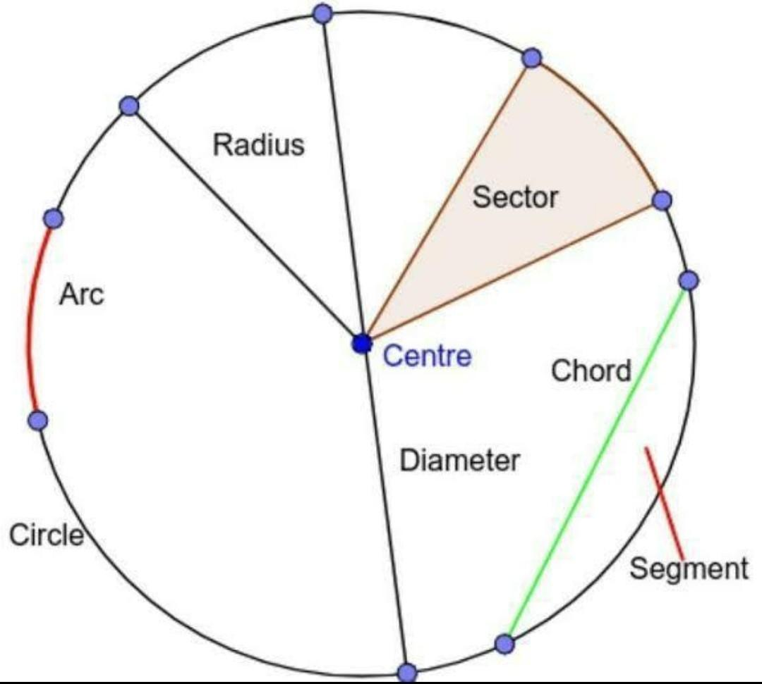
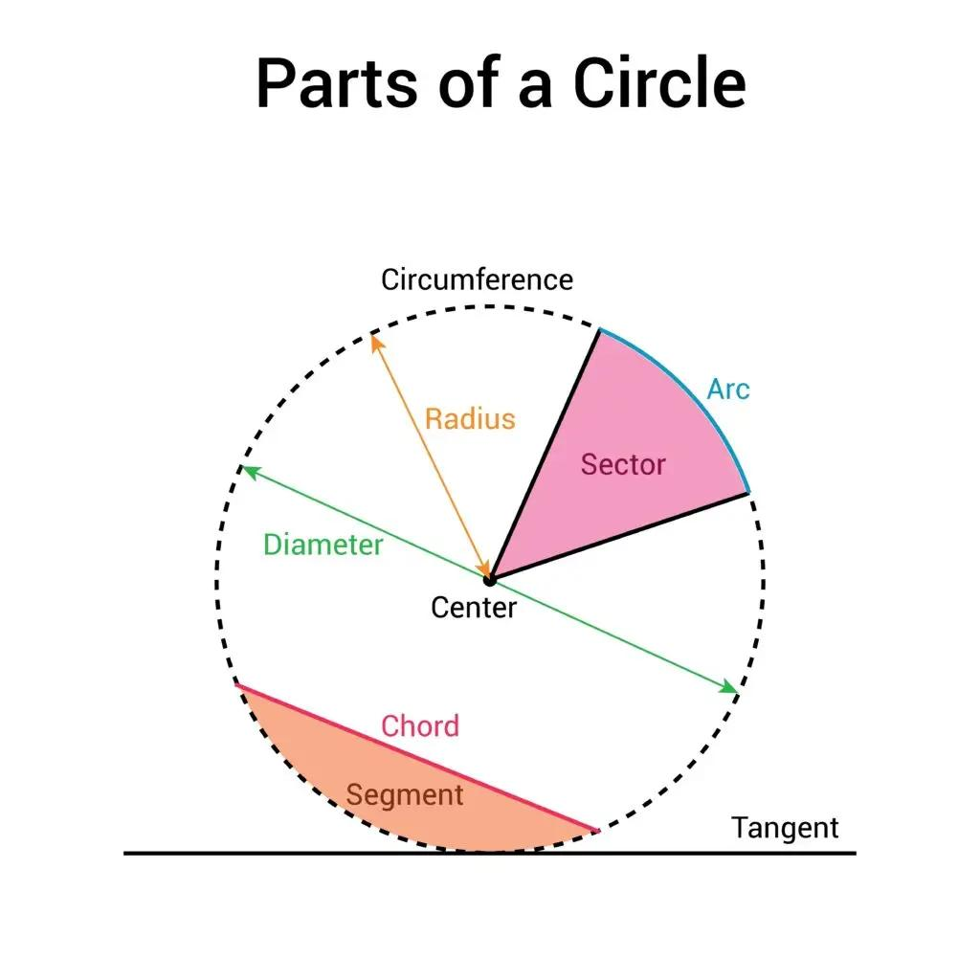
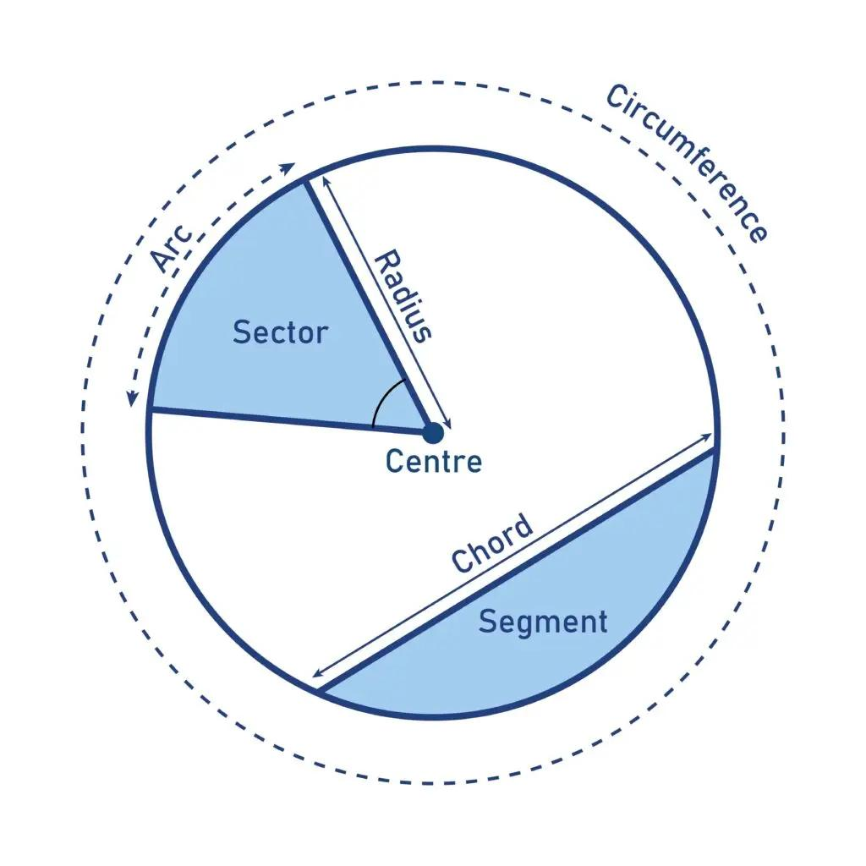
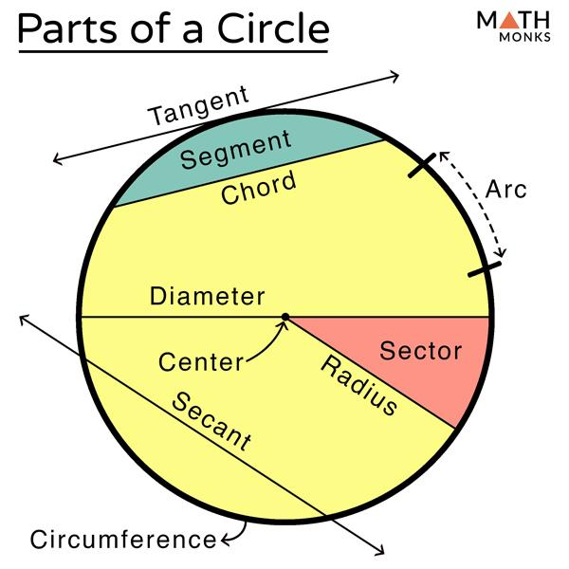

Polygon
# Source: AI Source: Provided by: [Data Path: Persons Table -> ID Column: 1, Name_En Column: Motasem Essam] -> From: [ChatGPT] on [7/25/2026]
A polygon is a closed plane figure bounded by a finite number of straight line segments.
Examples include:
- Triangle
- Quadrilateral
- Pentagon
- Hexagon
- Heptagon
- Octagon
- Nonagon
- Decagon
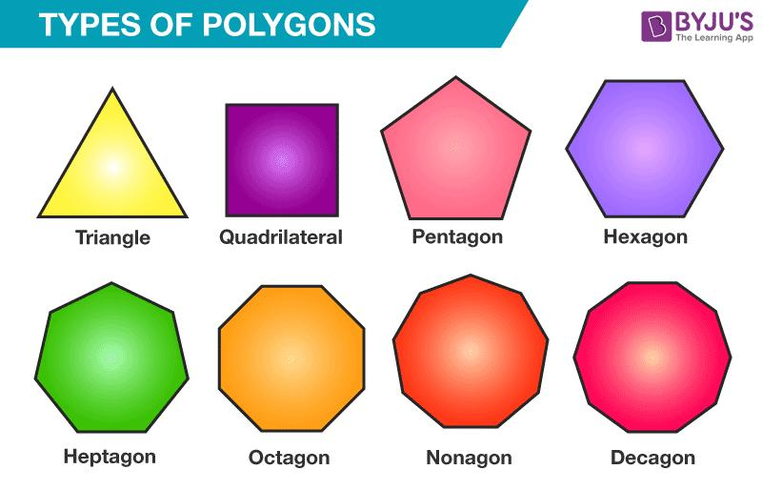
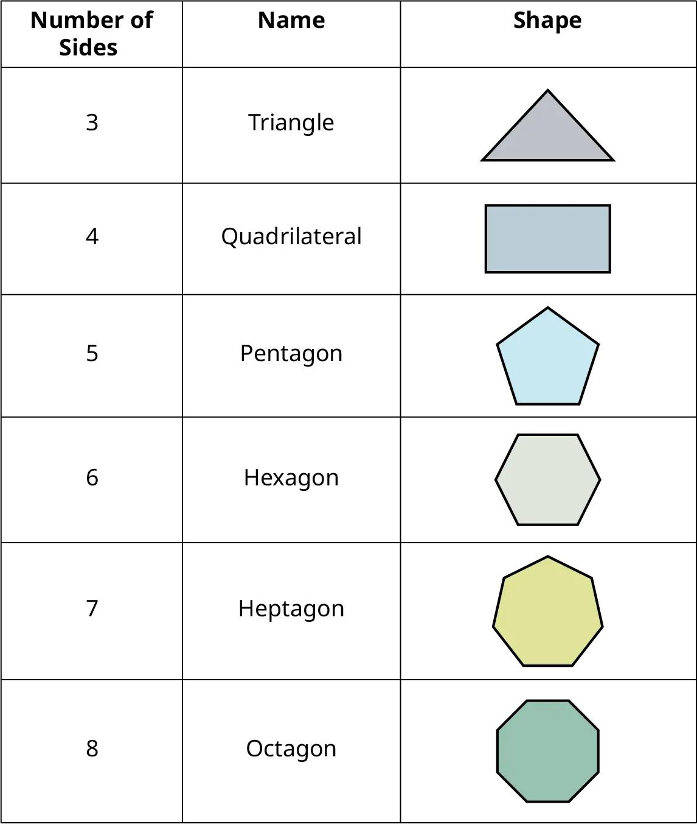
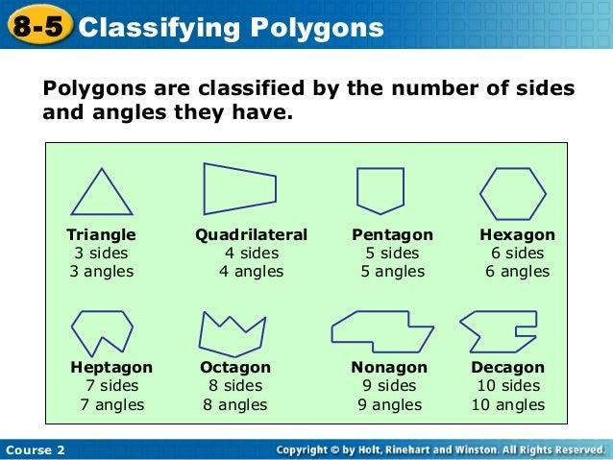
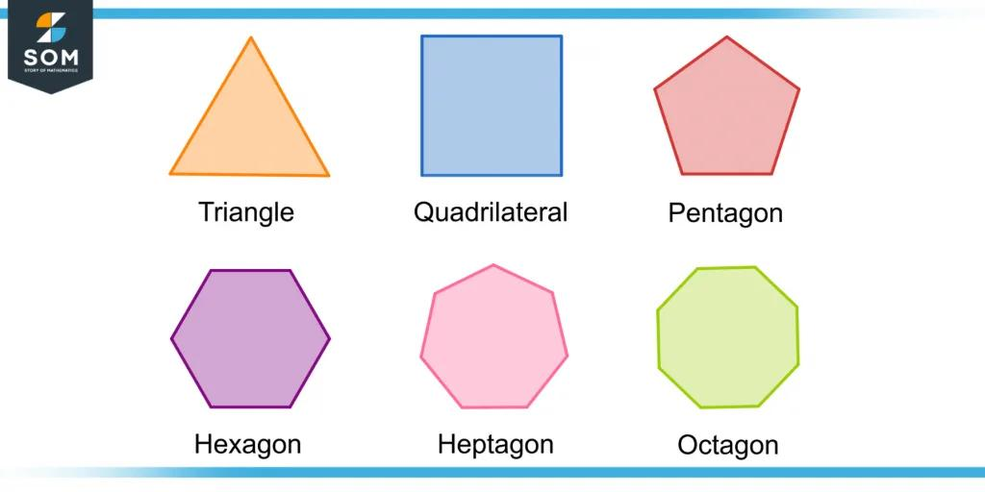

Open and Closed Geometric Figures
# Source: AI Source: Provided by: [Data Path: Persons Table -> ID Column: 1, Name_En Column: Motasem Essam] -> From: [ChatGPT] on [7/25/2026]
Geometric figures can also be classified according to whether their boundaries are connected.

Open Figure
# Source: AI Source: Provided by: [Data Path: Persons Table -> ID Column: 1, Name_En Column: Motasem Essam] -> From: [ChatGPT] on [7/25/2026]
An open figure does not return to its starting point.
Examples:
- Open curve
- Open polyline
- Ray
- Line

Closed Figure
# Source: AI Source: Provided by: [Data Path: Persons Table -> ID Column: 1, Name_En Column: Motasem Essam] -> From: [ChatGPT] on [7/25/2026]
A closed figure forms a complete boundary.
Examples:
- Circle
- Triangle
- Square
- Polygon
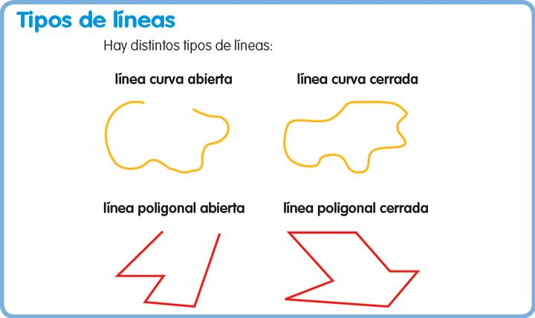
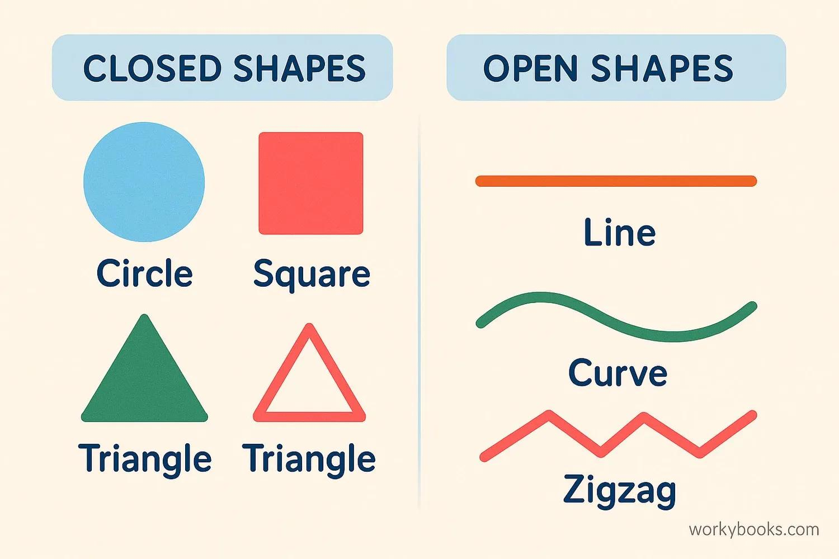
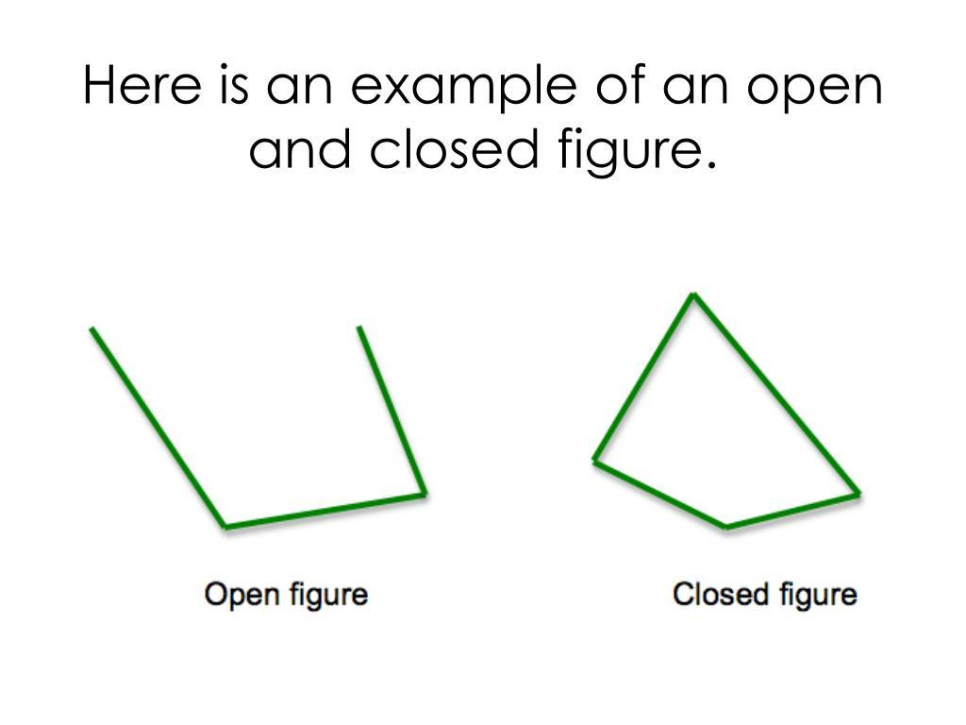
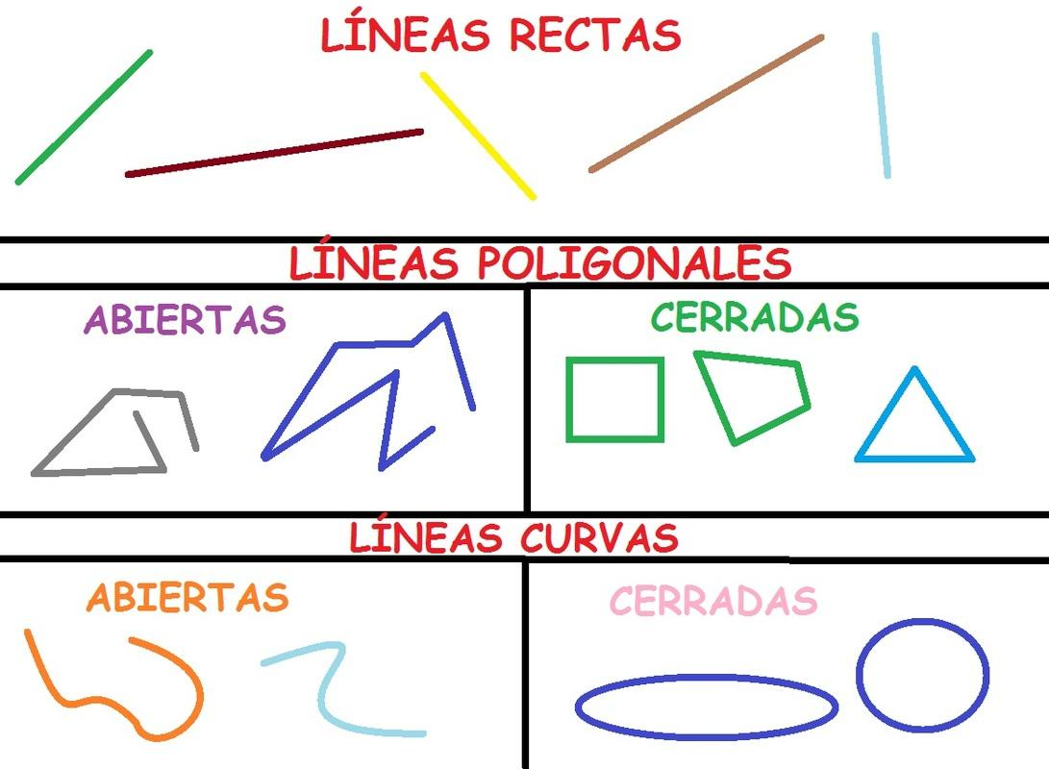
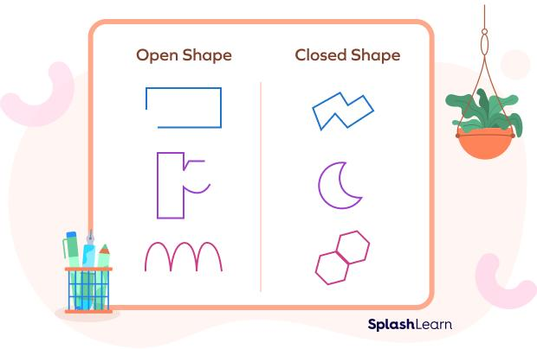

Straight and Curved Figures
# Source: AI Source: Provided by: [Data Path: Persons Table -> ID Column: 1, Name_En Column: Motasem Essam] -> From: [ChatGPT] on [7/25/2026]
Geometric figures can also be classified according to the type of boundary they contain.

Straight-Sided Figures
# Source: AI Source: Provided by: [Data Path: Persons Table -> ID Column: 1, Name_En Column: Motasem Essam] -> From: [ChatGPT] on [7/25/2026]
Figures whose boundaries consist entirely of straight line segments.
Examples:
- Triangle
- Square
- Rectangle
- Polygon

Curved Figures
# Source: AI Source: Provided by: [Data Path: Persons Table -> ID Column: 1, Name_En Column: Motasem Essam] -> From: [ChatGPT] on [7/25/2026]
Figures that contain curved boundaries.
Examples:
- Circle
- Ellipse
- Circular arc
Mixed Figures
# Source: AI Source: Provided by: [Data Path: Persons Table -> ID Column: 1, Name_En Column: Motasem Essam] -> From: [ChatGPT] on [7/25/2026]
Figures that contain both straight and curved sections.
Examples:
- Semicircle with a rectangular section.
- Shapes combining arcs and line segments.
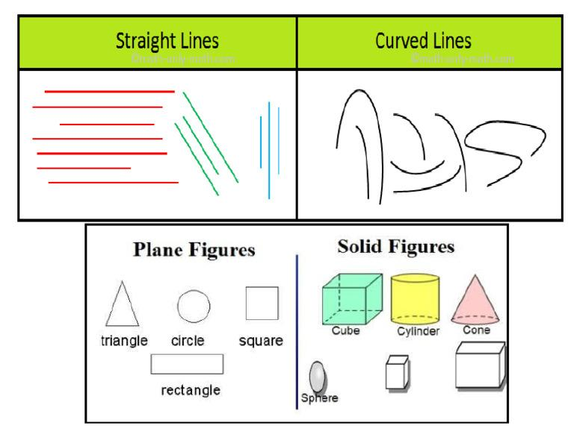
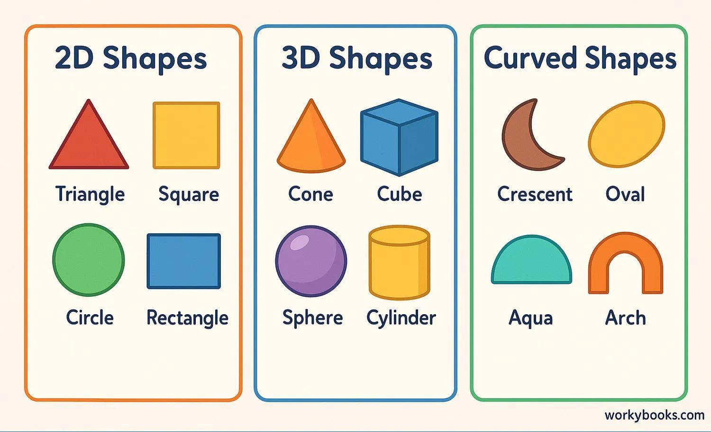
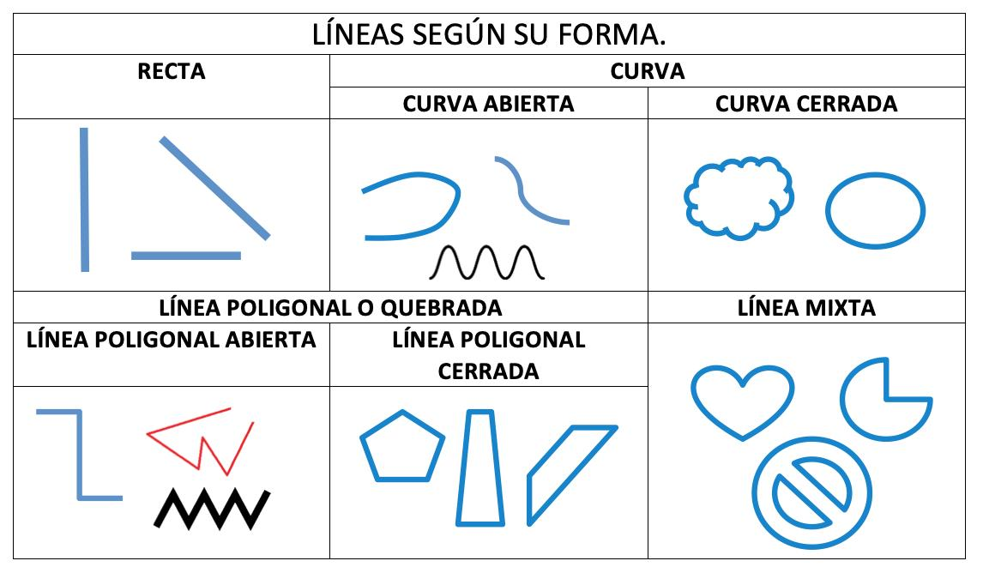
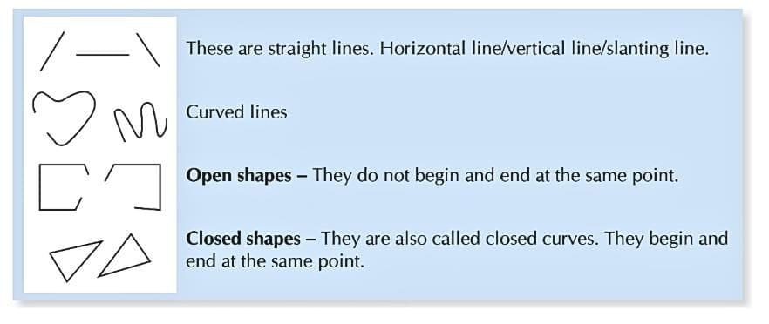

Geometric Properties
# Source: AI Source: Provided by: [Data Path: Persons Table -> ID Column: 1, Name_En Column: Motasem Essam] -> From: [ChatGPT] on [7/25/2026]
Geometric figures can be described using properties such as:
- Number of sides.
- Number of vertices.
- Number of angles.
- Side lengths.
- Angle measures.
- Perimeter.
- Area.
- Radius.
- Diameter.
- Symmetry.
- Orientation.
- Position.
For 3D figures, additional properties include:
- Faces.
- Edges.
- Vertices.
- Surface area.
- Volume.

Measurements of Geometric Figures
# Source: AI Source: Provided by: [Data Path: Persons Table -> ID Column: 1, Name_En Column: Motasem Essam] -> From: [ChatGPT] on [7/25/2026]
Common measurements include:
Length
$$L$$
Perimeter
The total distance around a closed 2D figure.
Area
The amount of plane region enclosed by a 2D figure.
Circumference
The distance around a circle.
$$C=2πr$$
Surface Area
The total area of the surfaces of a 3D object.
Volume
The amount of space occupied by a 3D object.

Common Formulas
# Source: AI Source: Provided by: [Data Path: Persons Table -> ID Column: 1, Name_En Column: Motasem Essam] -> From: [ChatGPT] on [7/25/2026]
Rectangle Area
$$A=l×w$$
Square Area
$$A=s^{2}$$
Triangle Area
$$A=\frac{1}{2}bh$$
Circle Area
$$A=πr^{2}$$
Circle Circumference
$$C=2πr$$
Rectangular Prism Volume
$$V=lwh$$
Cube Volume
$$V=s^{3}$$
Sphere Volume
$$V=\frac{4}{3}πr^{3}$$

Geometric Relationships
# Source: AI Source: Provided by: [Data Path: Persons Table -> ID Column: 1, Name_En Column: Motasem Essam] -> From: [ChatGPT] on [7/25/2026]
Geometric figures can have many relationships with one another.
These include:
- Congruence
- Similarity
- Symmetry
- Parallelism
- Perpendicularity
- Intersection
- Tangency
- Proportionality
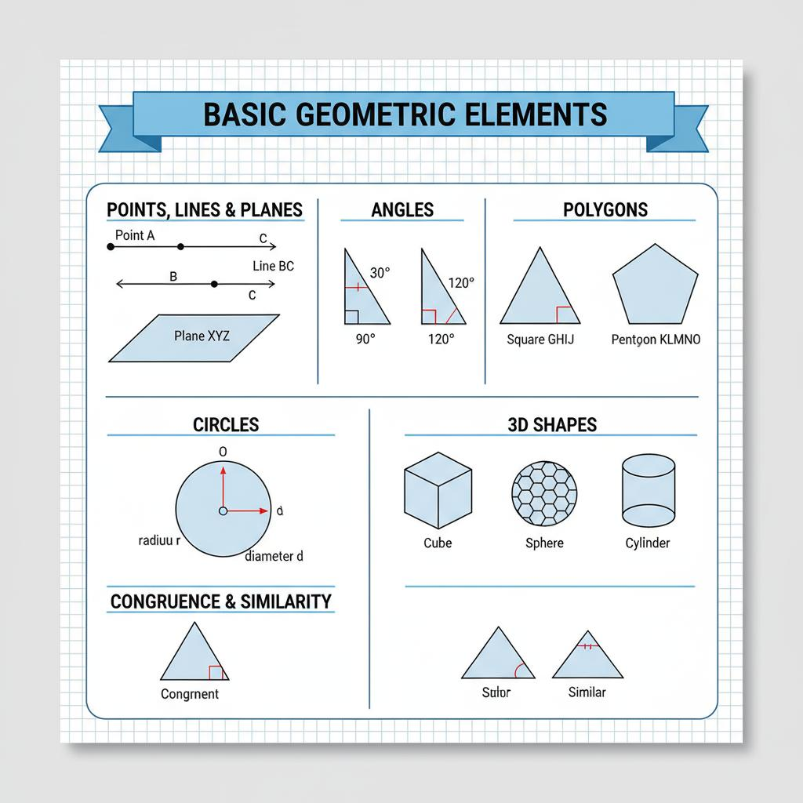
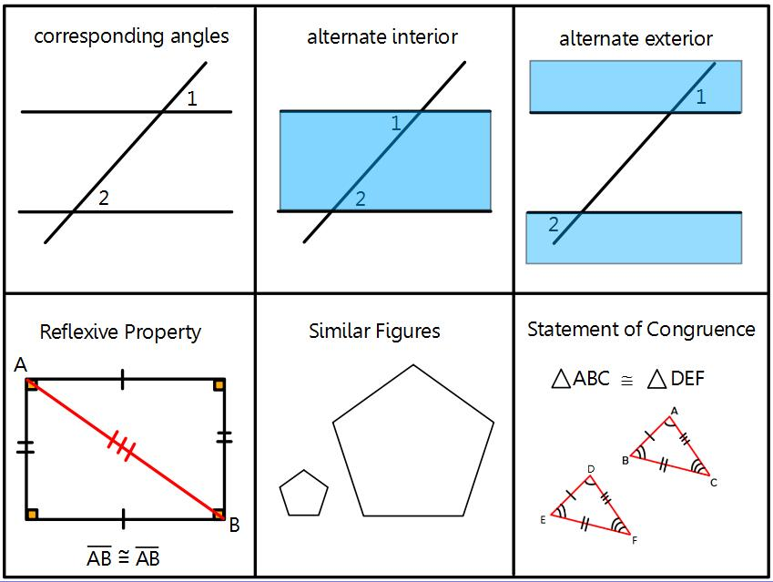
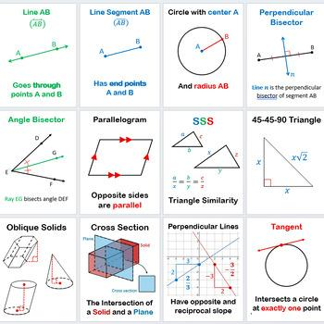
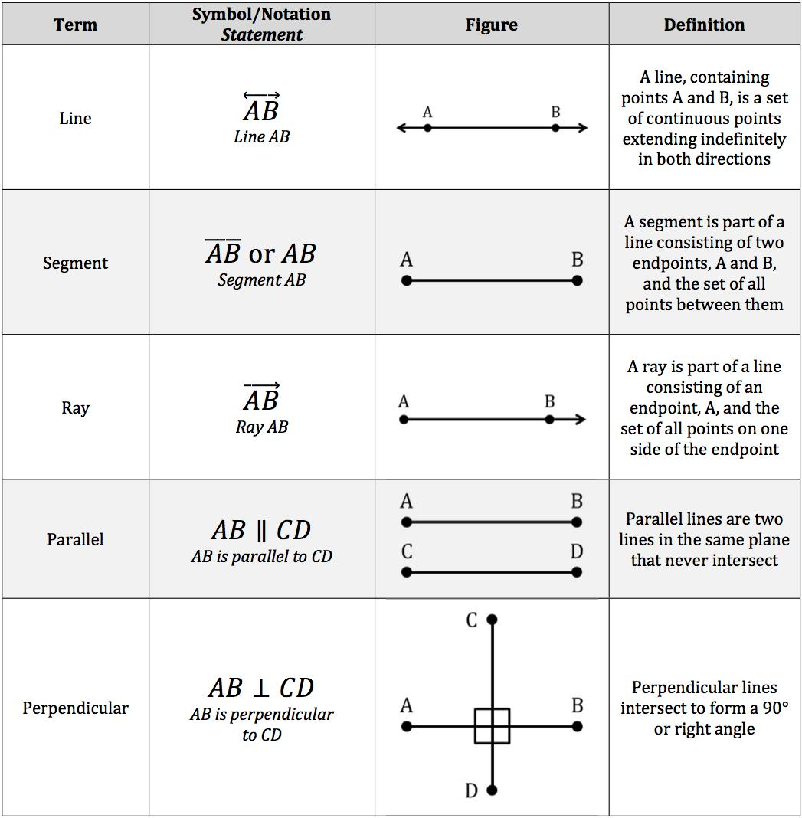
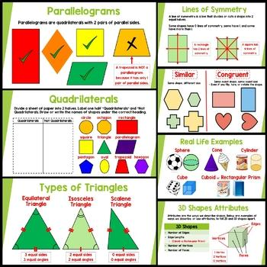

Transformations of Geometric Figures
# Source: AI Source: Provided by: [Data Path: Persons Table -> ID Column: 1, Name_En Column: Motasem Essam] -> From: [ChatGPT] on [7/25/2026]
A geometric figure can be transformed through:
Translation
Moving a figure.
Rotation
Turning a figure around a point.
Reflection
Flipping a figure across a line.
Dilation
Enlarging or reducing a figure.
Shear
Slanting a figure by shifting its points in a direction.

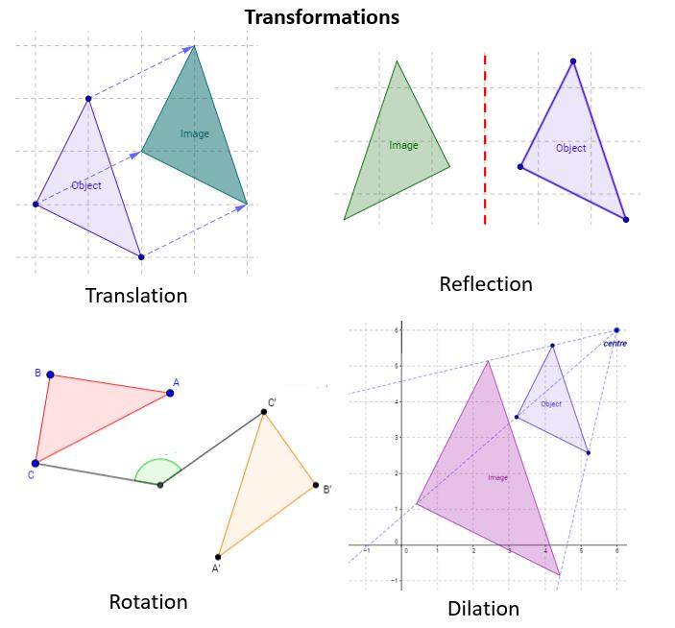
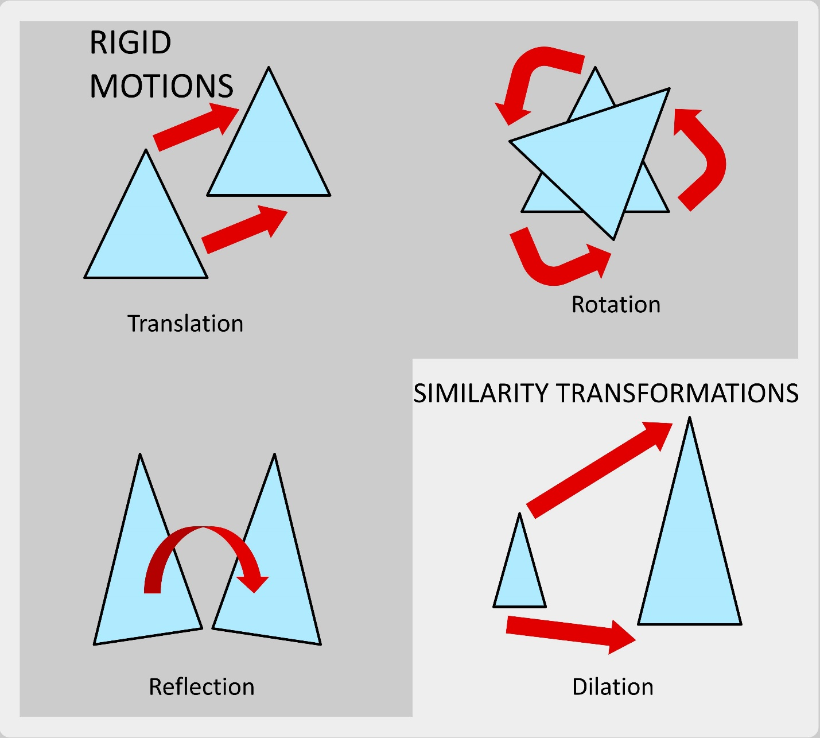
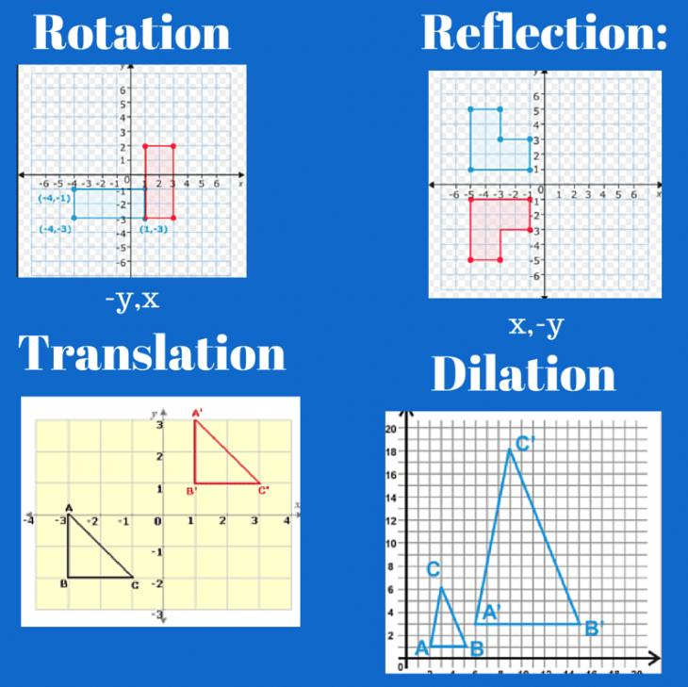
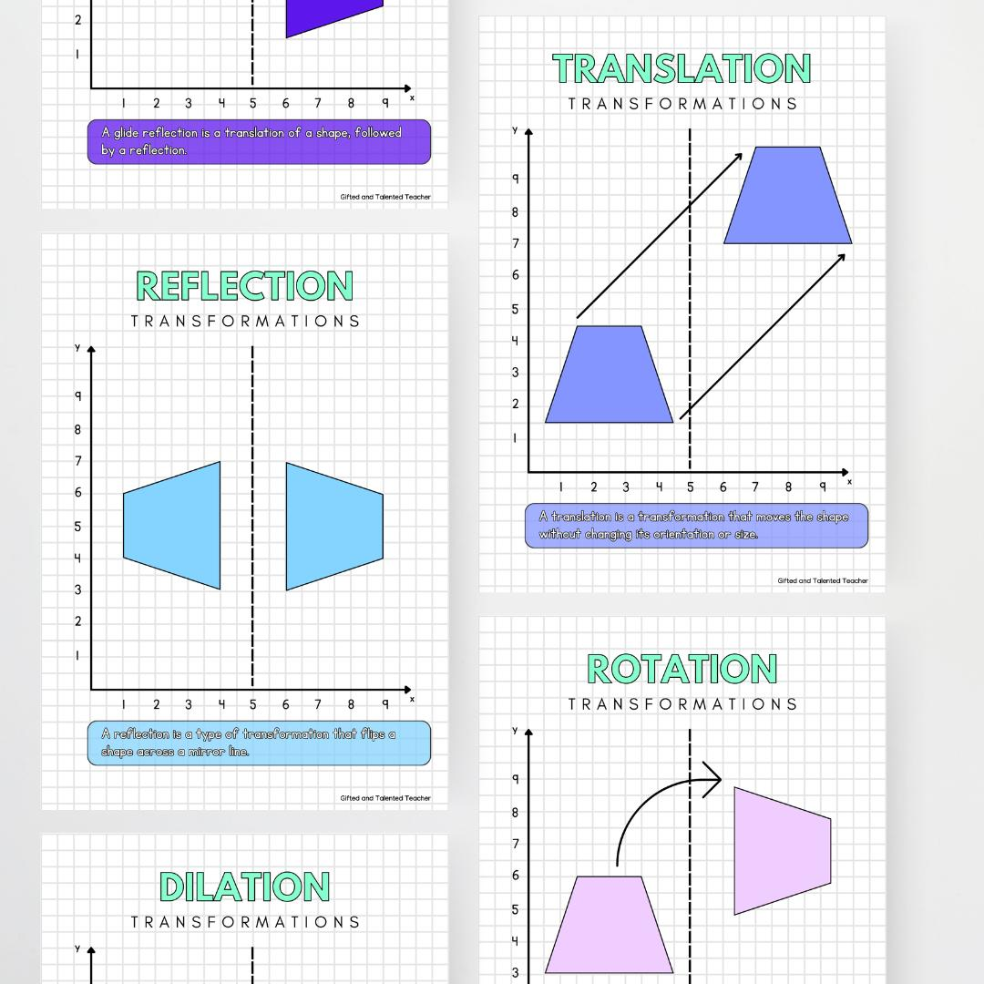
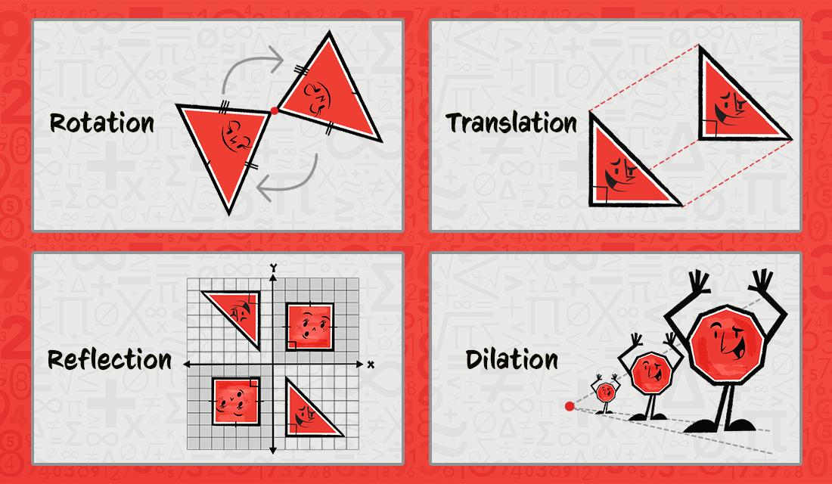

Real-World Examples
# Source: AI Source: Provided by: [Data Path: Persons Table -> ID Column: 1, Name_En Column: Motasem Essam] -> From: [ChatGPT] on [7/25/2026]
Geometric figures are found throughout the real world.
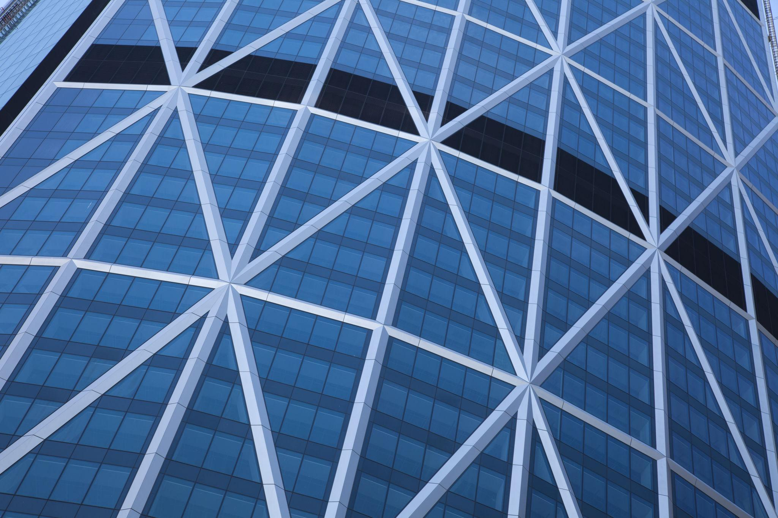
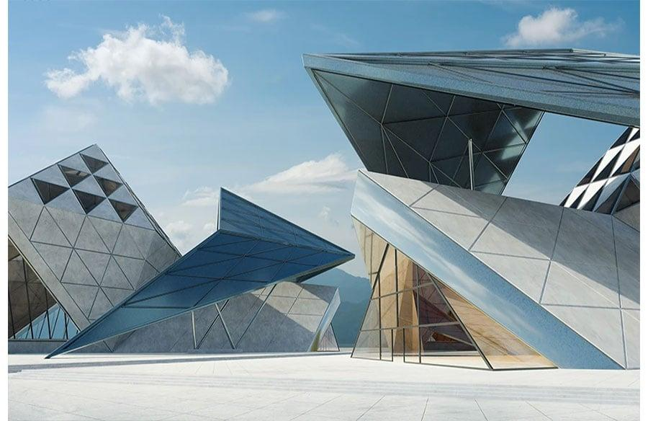
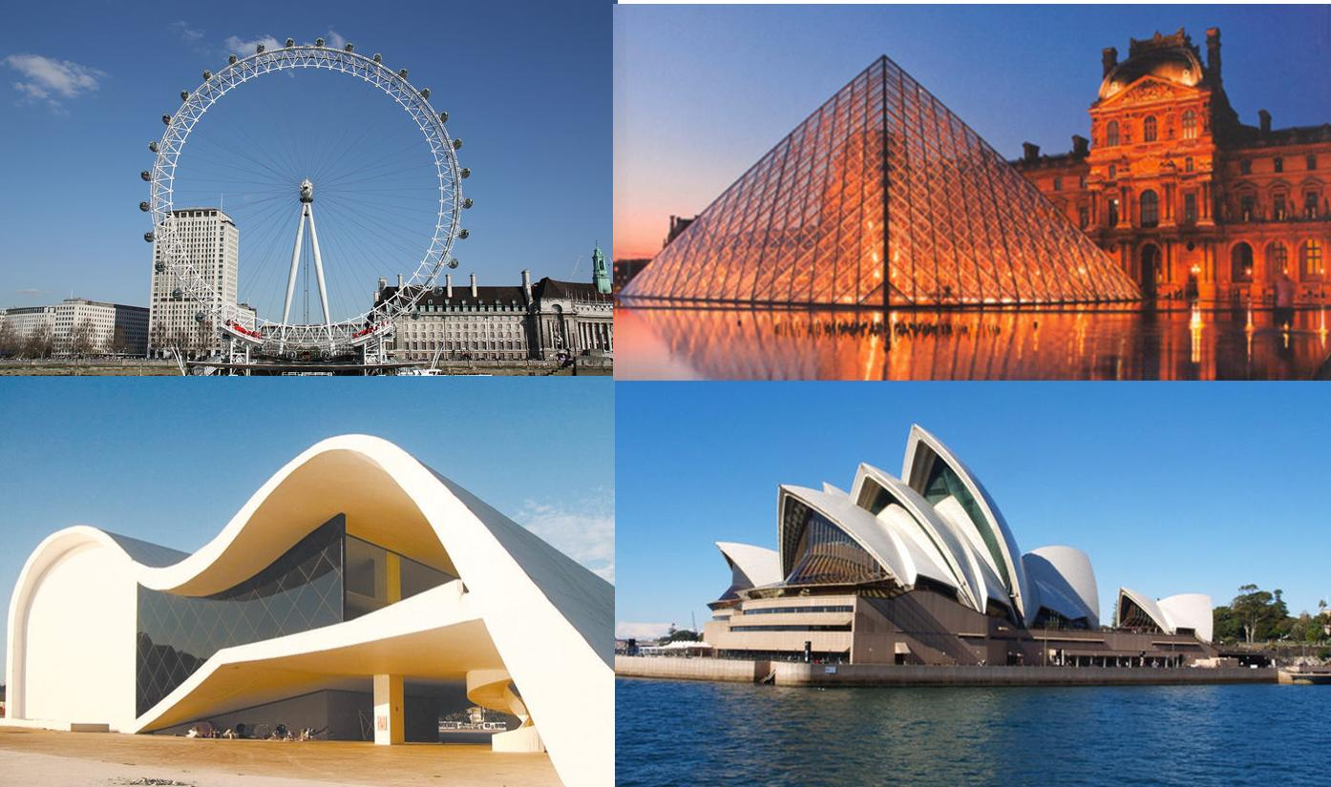
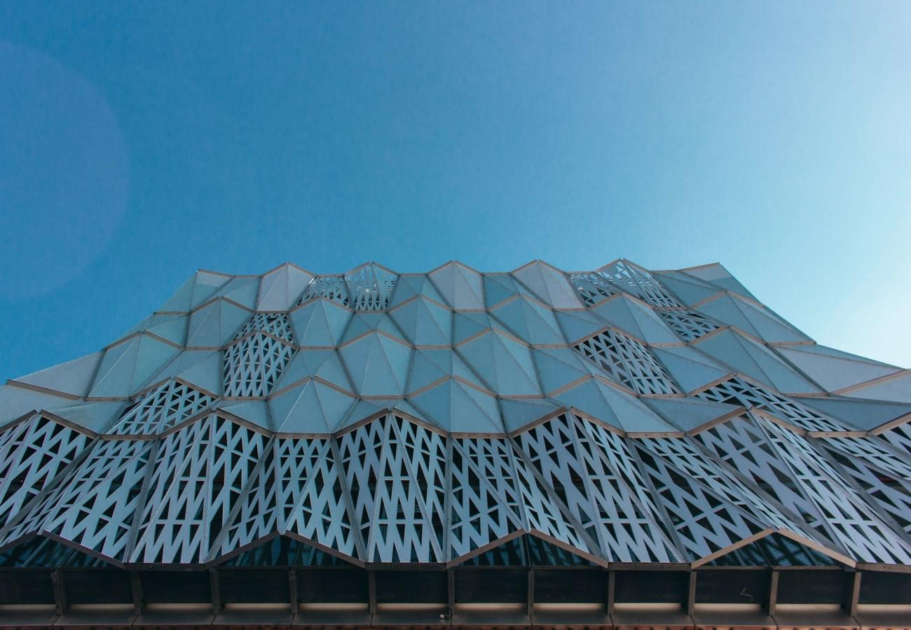
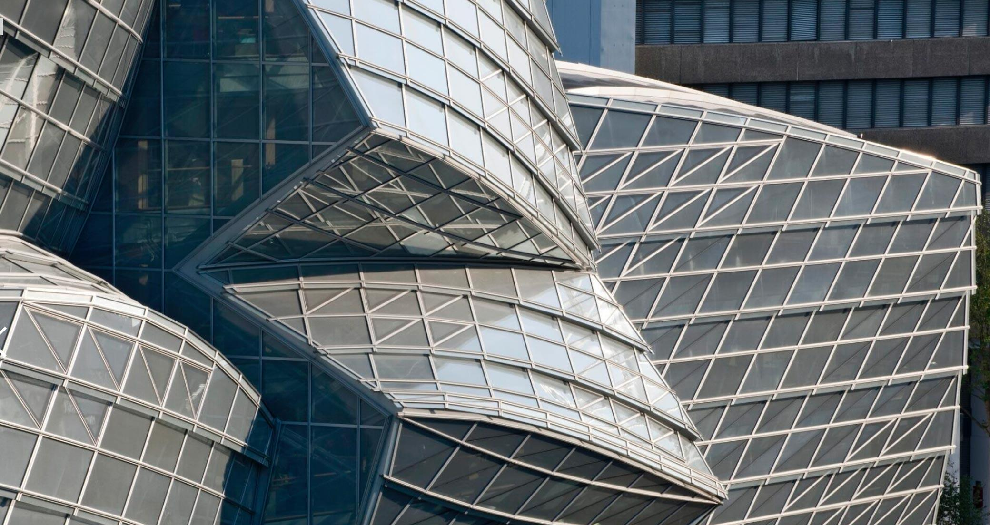
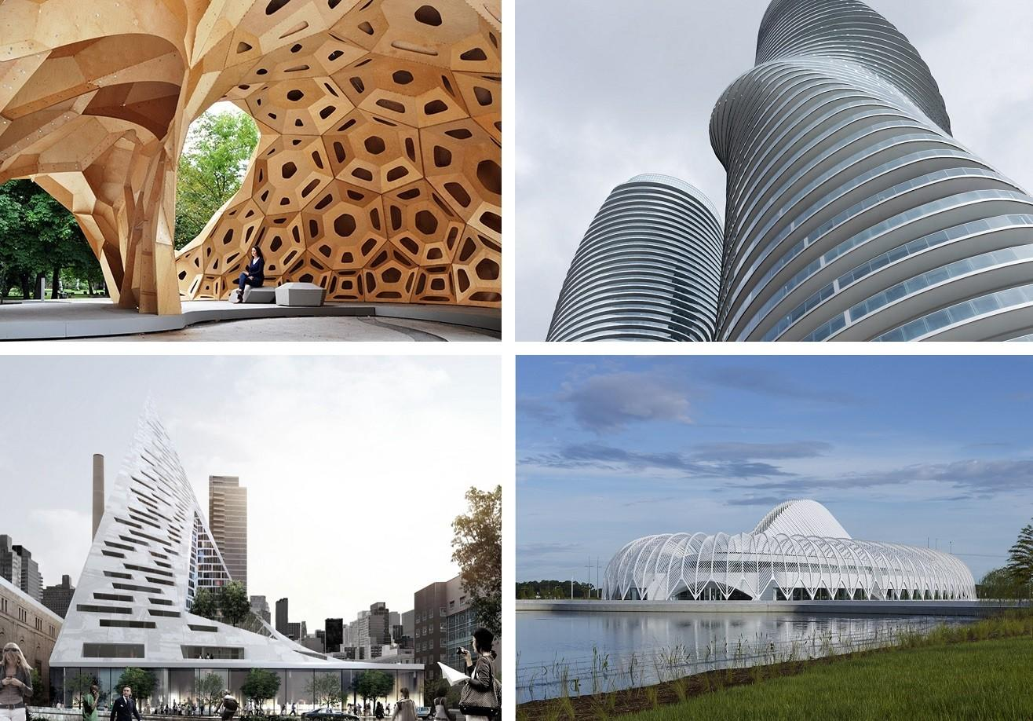
Examples include:
- Buildings
- Bridges
- Roads
- Windows
- Doors
- Wheels
- Signs
- Machines
- Packaging
- Furniture
- Maps
- Computer graphics

Applications
# Source: AI Source: Provided by: [Data Path: Persons Table -> ID Column: 1, Name_En Column: Motasem Essam] -> From: [ChatGPT] on [7/25/2026]
Geometric figures are important in:
- Plane Geometry
- Solid Geometry
- Coordinate Geometry
- Trigonometry
- Architecture
- Civil Engineering
- Mechanical Engineering
- CAD
- Computer Graphics
- Robotics
- Manufacturing
- Surveying
- Cartography
- Industrial Design

Advantages
# Source: AI Source: Provided by: [Data Path: Persons Table -> ID Column: 1, Name_En Column: Motasem Essam] -> From: [ChatGPT] on [7/25/2026]
Studying geometric figures helps to:
- Develop spatial reasoning.
- Understand shapes and structures.
- Perform measurements.
- Calculate areas and volumes.
- Compare geometric objects.
- Solve practical problems.
- Understand geometric relationships.
- Create accurate designs.
- Model real-world objects mathematically.

Limitations
# Source: AI Source: Provided by: [Data Path: Persons Table -> ID Column: 1, Name_En Column: Motasem Essam] -> From: [ChatGPT] on [7/25/2026]
Geometric figures:
- Often represent idealized mathematical objects.
- May simplify complex real-world objects.
- Require mathematical assumptions for accurate modeling.
- Two-dimensional figures cannot represent depth directly.
- Simple geometric models may not capture every detail of real objects.

Comparison of 2D and 3D Geometric Figures
# Source: AI Source: Provided by: [Data Path: Persons Table -> ID Column: 1, Name_En Column: Motasem Essam] -> From: [ChatGPT] on [7/25/2026]
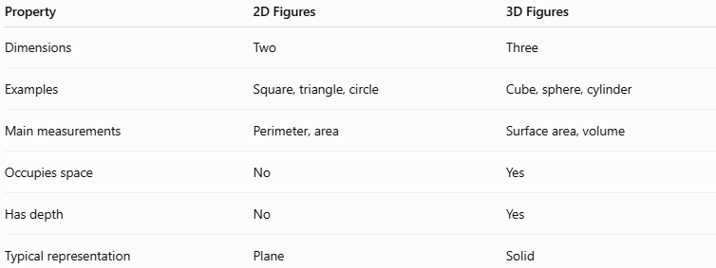
Property | 2D Figures | 3D Figures
Dimensions | Two | Three
Examples | Square, triangle, circle | Cube, sphere, cylinder
Main measurements | Perimeter, area | Surface area, volume
Occupies space | No | Yes
Has depth | No | Yes
Typical representation | Plane | Solid

Key Points
# Source: AI Source: Provided by: [Data Path: Persons Table -> ID Column: 1, Name_En Column: Motasem Essam] -> From: [ChatGPT] on [7/25/2026]
- Geometric Figures are mathematical objects used to represent shapes and structures.
- They can be 0D, 1D, 2D, or 3D.
- Common 2D figures include triangles, quadrilaterals, circles, and polygons.
- Common 3D figures include cubes, spheres, cylinders, cones, prisms, and pyramids.
- Figures can have straight, curved, or mixed boundaries.
- Geometric figures can be analyzed using properties such as length, angle, perimeter, area, surface area, and volume.
- They can also be compared through congruence, similarity, symmetry, and transformations.
- Geometric figures form a fundamental part of geometry and are widely used in mathematics, science, engineering, architecture, and design.

Conclusion
# Source: AI Source: Provided by: [Data Path: Persons Table -> ID Column: 1, Name_En Column: Motasem Essam] -> From: [ChatGPT] on [7/25/2026]
Geometric Figures are fundamental mathematical objects used to represent and study shapes, structures, and spatial relationships. They range from basic elements such as points, lines, rays, and line segments to two-dimensional figures such as triangles, quadrilaterals, circles, and polygons, and three-dimensional figures such as cubes, spheres, cylinders, cones, prisms, and pyramids. Studying their properties, measurements, relationships, and transformations provides the foundation for plane geometry, solid geometry, engineering, architecture, computer graphics, design, and many other mathematical and technical fields.

